Acknowledgement

This project has been a dedicated effort towards development of a highly autonomous artificial intelligence, which primarily would not have been possible at the first place without the apt guidance of the Head of Networking Department, respected Prof. Dr. Bharat Chaudary. His motivation and encouragement during the project made me go further than expected in the development process and the redaction of this current report.

I would also like to thank Pr. Daniel Schang from ESEO-France who the first explained to me the concept of Ants Algorithm through very pertinent seminars, and provided me with a relevant example of implementation; Pr. Dr. Mesut Günes from Computer systems and telematics, FU Berlin, and member of the Mobile Communication Group, who developed a well-known routing protocol based on ants, for taking interest to my code and distributing my application on his website; and Pr. Dr. Drake Ramore from Dool, for his precious advice.

This dedication would not be complete without expressing my gratitude towards all staff members and my dear classmates for their interest and curiosity toward my project, where definitely to talk about an insect can sound curious.



International Institute of Information Technology
P-14, Pune Infotech Park, Hinjewadi, Pune-411057, India

Certificate

This is to certify that Mr. Jonathan Vaslin of September 06 batch has satisfactorily completed a project entitled, “Ant Colony Optimization: An adaptative nature inspired algorithm explained, concretely implemented, and applied to routing protocols in wired and wireless networks” as part of the third trimester curriculum of Masters of Science Programme in Advanced Information Technology (MSP-AIT) with specialisation in Advanced Networking and Telecommunication of this Institute.

Date: Dr. Bharat Chaudhari
Place: Pune Guide and Head
Department of Advanced Networking and Telecom

Seal of the Institute

Abstract

All networks tend to become more and more complicated. They can be wired, with lots of routers, or wireless, with lots of mobile nodes… The problem remains the same: in order to get the best from the network, there is a need to find the shortest path. The more complicated the network is, the more difficult it is to manage the routes and indicate which one is the best.

The Nature gives us a solution to find the shortest path. The ants, in their necessity to find food and brings it back to the nest, manage not only to explore a vast area, but also to indicate to their peers the location of the food while bringing it back to the nest. Thus, they know where their nest is, and also their destination, without having a global view of the ground. Most of the time, they will find the shortest path and adapt to ground changes, hence proving their great efficiency toward this difficult task.

The purpose of this project is to provide a clear understanting of the Ants-based algorithm, by giving a formal and comprehensive systematization of the subject. The simulation developed in Java will be a support of a deeper analysis of the factors of the algorithm, its potentialities and its limitations. Then the state-of-the-arts utilisation of this algorithm and its implementations in routing algorithms, mostly for mobile ad hoc networks, will be explained. Results of recent studies will be given and resume the current employments of this great algorithm inspired by the Nature.

Objectives
- Propose an easy approach to the Ant Colony Algorithm, with appropriated vocabulary and global explanation, as well as details about its behaviour.
- Develop a Java application which shows the working of the algorithm and gives a better understanding.
- Give a straightforward analysis of the state-of-the-art studies on Ants-based Routing Algorithms and the implementations which have been done.

List of content
1 Acknowledgement 1
2 Abstract 3
2.1 Objectives: 3
3 List of content 4
4 List of figures / tables 6
1 Introduction 7
1.1 The source of inspiration: the Ants 7
1.2 The Double Bridge Experiment 8
1.3 From Biological Ants to Ants-Agents 12
1.4 The Pheromones 14
2 Implementation of The Ants-based Algorithm in Java 16
2.1 The ideas behind the simulation 16
2.1.1 Selection of the language 16
2.1.2 Object modeling 16
2.2 The two main classes 19
2.2.1 The class Ant 19
2.2.2 The Playground class 26
2.3 The application 29
2.3.1 How to use, how it works 29
2.3.2 Results 31
3 analysis of the state-of-the-art Adaptations oF the Ants-based Algorithms to routing protocols 39
3.1 Why and How to apply an Ant-Based algorithm to routing protocols 39
3.1.1 Routing Information 40
3.1.2 Information overhead 41
3.1.3 Adaptivity 42
3.2 Presentation of the selected papers 42
3.2.1 Ant-based load balancing in telecommunications networks 43
3.2.2 AntNet A Mobile Agents Approach to Adaptive Routing 45
3.2.3 Routing Algorithms for Mobile Multi-Hop Ad Hoc Networks 48
3.2.4 Ant Colony Optimization for Routing and Load-Balancing: Survey and New Directions 50
3.2.5 Ants-Based Routing in Mobile Ad Hoc Networks 51
3.2.6 Using Ant Agents to Combine Reactive and Proactive Strategies for Routing in Mobile Ad Hoc Networks 53
3.2.7 Proposal on Multi agent Ants based Routing Algorithm for Mobile Ad Hoc Networks 55
3.3 List of Ants-based routing algorithms 56
3.3.1 Previous MANET routing protocols 56
3.3.2 Routing protocols presented in this paper 56
4 Conclusion 58
5 Appendix 59
5.1 Class Diagram 59
5.2 Start.java 61
5.3 Ant.java [object] 63
5.4 Playground.java [object] 71
5.5 Nodes.java [object] 76
5.6 Traces.java [object] 77
5.7 SerializerNodes.java [object] 79
5.8 PlaygroundMouseListener [gui] 81
5.9 PlaygroundMouseMotionListener [gui] 82
5.10 JMenuPanel.java [gui] 83
5.11 ButtonListener.java [gui] 85
5.12 ButtonStart.java [gui] 87
6 References 88

List of figures / tables

Illustration1.1 Picture of ants 7
Fig1.2 Ants and pheromones 9
Fig1.3 The Double Bridge Experiment 10
Fig1.4 Ants exploring the double bridge 10
Fig1.5 Ants coming back to the nest 11
Illustration1.6 Ant 15

Fig2.1 Basic Class Diagram 17
Fig2.2 Full Class Diagram (see in Appendix 1) 18
Fig2.3 The ants leaving the nest at t=5 22
Fig2.4 The ants leaving the nest at t=10 23
Fig2.5 The Application’s Look 29
Fig2.6 The Playground options 30
Fig2.7 The Application during a simulation and Fig2.8 Changes in the playground 31
Fig2.9 A difficult playground 32
Fig2.10 Convergence with default factors on the difficult playground 33
Fig2.11 The AntSim v1.0 application 34
Fig2.12 AntSim v1.0 settings and Fig2.13 AntSim v1.0 statistics 35
Fig2.14 Ant Foraging 35
Fig2.15 StarLogo Ant Foraging decision 36
Fig2.16 The Ant Viewer 37
Fig2.17 The two-bridge experiment by Rennard 37
Fig2.18 Ants eating a chocolate donut 38

Fig3.1 Nodes 40
Fig3.2 SDH network simulation for ABC system 44
Fig3.3 The virtual network for AntNet simulation 47
Illustration 3.4 Ant eating a watermelon 57

Introduction

The source of inspiration: the Ants

Ant as a single individual has a very limited effectiveness. But as a part of a well-organised colony, it becomes one powerful agent, working for the development of the colony. The ant lives for the colony and exists only as a part of it. Ant colonies are sometimes described as superorganism because it appears to operate as a unified entity.
Each ant is able to communicate, learn, cooperate, and all together they are capable of develop themselves and colonise a large area. They manage such great successes by increasing the number of individuals and being exceptionally well organised. The self organising principles they are using allow a highly coordinated behaviour of the colony, furthermore bring them to accomplish complex tasks, whose difficulty far exceed the individual capabilities of a single ant.

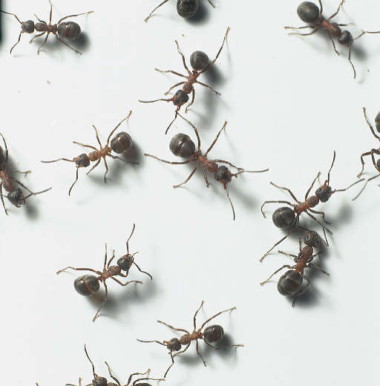
Illustration1.1 Picture of ants

Pierre Paul Grassé, a French entomologist, was one of the first researchers who investigate the social behaviour of insects. He discovered that these insects are capable to react to what he called “significant stimuli," signals that activate a genetically encoded reaction. He observed that the effects of these reactions can act as new significant stimuli for both the insect that produced them and for the other insects in the colony. Grassé used the term stigmergy to describe this particular type of indirect communication in which “the workers are stimulated by the performance they have achieved”.

Stigmergy is defined as a method of indirect communication in a self-organizing emergent system where its individual parts communicate with one another by modifying their local environment.
Ants communicate to one another by laying down pheromones along their trails, so where ants go within and around their ant colony is a stigmergic system. Similar phenomena can be observed for some animals, such as termites, which use pheromones to build their very complex nests by following a simple decentralized rule set. Each insect scoops up a 'mudball' or similar material from its environment, invests the ball with pheromones, and deposits it on the ground. Termites are attracted to their nestmates' pheromones and are therefore more likely to drop their own mudballs near their neighbors'. Over time this leads to the construction of pillars, arches, tunnels and chambers.

In many ant species, ants walking from or to a food source, deposit on the ground a substance called pheromone. Other ants are able to smell this pheromone, and its presence influences the choice of their path, that is, they tend to follow strong pheromone concentrations. The pheromone deposited on the ground forms a pheromone trail, which allows the ants to find good sources of food that have been previously identified by other ants.
Using random walks and pheromones within a ground containing one nest and one food source, the ants will leave the nest, find the food and come back to the nest. After some time, the way being used by the ants will converge to the shortest path.

The Double Bridge Experiment

The ants begin by walking randomly. They cannot see the ground and have a very limited view of what is around them. Therefore, if the ground has not been explored yet, they will just wander and take random decision at each crossroads.
After a while, the places around the nest will be all explored. The ants will get to know that by the marking done by the previous ants. Indeed, they will leave behind them the famous pheromones and inform the other ants that the way is already explored.
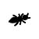
pheromones
Fig1.2 Ants and pheromones
The concentration of pheromones depends on the number of ants who took the way, the more ants taking the way, the more pheromones.

Deneubourg et al. verified the pheromones marking of ants by the experience known as “double bridge experiment”. The configuration is as shown in figure 1.2: the nest of a colony of ants is connected to the food via two bridges of the same length. In such a setting, ants start to explore the surroundings of the nest and eventually reach the food source. Along their path between food source and nest, ants deposit pheromones. Initially, each ant randomly chooses one of the two bridges. However, due to random fluctuations, after some time one of the two bridges presents a higher concentration of pheromones than the other and, therefore, attracts more ants. This brings a further amount of pheromone on that bridge making it more attractive with the result that after some time the whole colony converges toward the use of the same bridge.

Food
Fig1.3 The Double Bridge Experiment

The second experimentation, figure1.3 gives also two paths to the food source, but one of them is twice longer than the other one. Here again the ants will start to move randomly and explore the ground. Probabilistically, 50% of the ants will take the short way while the 50% others will take the long way, as they have no clue about the ground configuration.

Food
Fig1.4 Ants exploring the double bridge

The ants taking the shorter path will reach the food source before the others, and leave behind them the trail of pheromones. After reaching the food, they will turn back and try to find the nest. At the cross, one of the paths will contain pheromones although the other one will be not explored. Hence the ant which carries the food will take the path already explored, as it means it is the way to the nest.

Food
Fig1.5 Ants coming back to the nest

As the ant is choosing the shortest way and will continue to deposit pheromones, the path will therefore become more attractive for others. The ants who took the long way will have more probability to come back using the shortest way, and after some time, they will all converge toward using it.

Consequently, the ants will find the shortest path by themselves, without having a global view of the ground. By taking decision at each cross according to the pheromones amount, they will manage to explore, find the food, and bring it back to the nest, in an optimized way.

From Biological Ants to Ants-Agents
« I am lost ! Where is the line ?”
A Bug’s Life, Walt Disney, 1998

The transposition of the ants into an algorithm is made with the help of agents. These ants-agents will have the responsibility to locally and autonomously take decisions. The algorithm is shared between a large number of agents which will perform tasks simultaneously instead of having one decision-maker for the whole colony.

The decisions are based on a random choice, whose factors are the amounts of pheromones. Thus the macroscopic development of the colony comes from microscopic decisions, using ground-marking process. This algorithm is shared among all the agents and made the evolutions very fast.

In a computer-based simulation, the ants are replaced by agents which will explore the ground, let pheromones and once the goal reached try to come back. Goss et al., developed a model to explain the behavior observed in the double bridge experiment. Assuming that after t time units since the start of the experiment, m1 ants had used the first bridge and m2 the second one, the probability p1 for the (m + 1)th ant to choose the first bridge can be given by:
$$p_{1(m+1)}=\frac{(m_{1}+k)^{h}}{(m_{1}+k)^{h}+(m_{2}+k)^{h}}$$
where parameters k and h are needed to fit the model to the experimental data. The probability that the same (m+1)th ant chooses the second bridge is p2(m+1) = 1 -p1(m+1). Monte Carlo simulations, run to test whether the model corresponds to the real data, showed very good fit for k=20 and h=2.

This basic model, which explains the behaviour of real ants, may be used as an inspiration to design artificial ants that solve optimization problems defined in a similar way. In the above described experiment, stigmergic communication happens via the pheromone that ants deposit on the ground. Analogously, artificial ants may simulate pheromone laying by modifying appropriate pheromone variables associated with problem states they visit while building solutions to the optimization problem. Also, according to the stigmergic communication model, the artificial ants would have only local access to these pheromone variables.
Therefore, the main characteristics of stigmergy mentioned in the previous section can be extended to artificial agents by:
- Associating state variables with different problem states
- Giving the agents only local access to these variables.

Another important aspect of real ants' foraging behaviour that may be exploited by artificial ants is the coupling between the convergence mechanism and the implicit evaluation of solutions. By implicit solution evaluation, we mean the fact that shorter paths (which correspond to lower cost solutions in the case of artificial ants) are completed earlier than longer ones, and therefore they receive pheromone reinforcement quicker. Implicit solution evaluation coupled with autocatalysis can be very effective: the shorter th the shorter the path, the sooner the pheromone is deposited, and the more ants use the shorter path. Stigmergy, together with implicit solution evaluation and autocatalytic behaviour, gave rise to Ants-based algorithms. The basic idea of Ants-based algorithms follows very closely the biological inspiration. Therefore, there are many similarities between real and artificial ants. Both real and artificial ant colonies are composed of a population of individuals that work together to achieve a certain goal. A colony is a population of simple, independent, asynchronous agents that cooperate to find a good solution to the problem at hand. In the case of real ants, the problem is to find the food, while in the case of artificial ants, it is to find a good solution to a given optimization problem. A single ant (either a real or an artificial one) is able to find a solution to its problem, but only cooperation among many individuals through stigmergy enables them to find good solutions.
In the case of real ants, they deposit and react to a chemical substance called pheromone. Real ants simply deposit it on the ground while walking. Artificial ants live in a virtual world, hence they only modify numeric values (called for analogy artificial pheromones) associated with different problem states. A sequence of pheromone values associated with problem states is called artificial pheromone trail. In Ants-based algorithms, the artificial pheromone trails are the sole means of communication among the ants.
Just like real ants, artificial ants create their solutions sequentially by moving from one problem state to another. Real ants simply walk, choosing a direction based on local pheromone concentrations and a stochastic decision policy. Artificial ants also create solutions step by step, moving through available problem states and making stochastic decisions at each step. There are however some important differences between real and artificial ants:
- Artificial ants live in a discrete world: they move sequentially through a finite set of problem states.
- The pheromone update is not accomplished in exactly the same way by artificial ants as by real ones. Sometimes the pheromone update is done only by some of the artificial ants, and often only after a solution has been constructed.
- Some implementations of artificial ants use additional mechanisms that do not exist in the case of real ants. Examples include look-ahead, local search, backtracking, etc.

The Pheromones

Pheromones represent in some ways the common memory. The fact that it is external and not a part of the ants / agents, confers to it an easy access for everyone. The memory is saved in without regarding the configuration of the ground, the number of ants, etc. It is totally independent, and still remains extremely simple.

Pheromones are just values stored in a 2-dimensional array, in reality like in algorithm, in a discrete way though.

In our implementation we will see that two different types of pheromones are used. The first one is represented in red and is let by the ants which do not carry the food. We will call it the Away pheromone, as it means that the ant is going away from the nest. Oppositely, the ants which carry the food to bring it back to the nest let a blue trace behind them, the Back pheromone.

Pheromones just proceed to one task: nature will take care of it in the real life, although it is a simple process in algorithms. In course of time, a global reduction of the pheromones by a certain factor is applied, simulating the evaporation process. Thus the non-succeeding path will see their concentration of pheromones reduced, although good solutions will stay full of pheromones as the ants keep using it. The convergence is very influenced by the factor of evaporation, and we will see how important it is in the simulation.

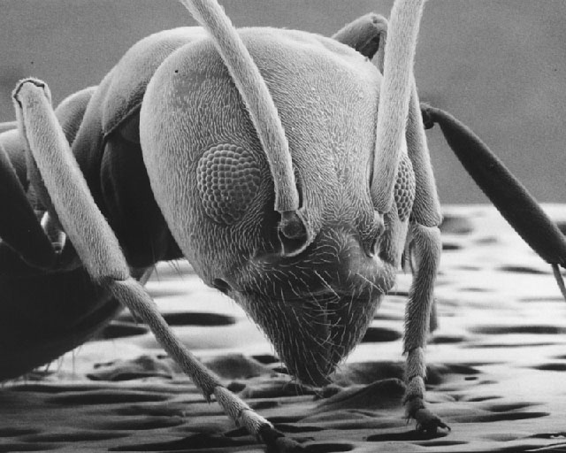
Illustration1.6 Ant

Implementation of The Ants-based Algorithm in Java

The ideas behind the simulation

Selection of the language
After deciding to code the algorithm, the first step is to decide which language to use. The algorithm is entirely based on objects which are independent one another. Therefore the choice goes straight to any Object-Oriented language, the most common ones being C++, C# and Java.
Since the application needs a GUI, the language needs to provide an easy access to the graphical environment with a simple interface with the mouse or keyboard.
Java is very polyvalent and really applies to these requirements. It is also multi-platform and with the applet helps, the application can be available on any internet webpage. Eclipse is an open-source software framework, which we will use as an IDE – Integrated Development Environment. It really helps in the development process, integrates with UML and thus saves a lot of time.

Object modeling
A modeling language is any artificial language that can be used to express information or knowledge or systems in a structure that is defined by a consistent set of rules. The rules are used for interpretation of the meaning of components in the structure.

In order to develop an application which really suits to the definitions, the first action is to give a complete modeling of the specifications. First the problem will be divided into classes, linked to one another and resuming the simulated world.
We can easily define 3 main classes:
- Ant. Agent which can smell the pheromones and make a move on the ground.
- Ground. Here we will call it Playground; it is the 2-dimension space which contains the ants and the pheromones.
- Pheromones. Or traces, they are the trails which partially lead the ants.

The next modeling step is to define the relationships between these objects. There are 4 main types of link, each of them basically defining the existence of a class when the other class is destroyed. UML shows the following relationships:
- Link. Basic relationship among objects.
- Association. Family of links whose multiplicity is unlimited.
- Aggregation. When a class is a collection of other classes, but where, if the container is destroyed, its content is not.
- Composition. The multiplicity has to be 0…1 or 1, and when the container is destroyed, its content is destroyed as well.

The Playground is the central class, the ants and the traces are around it. We can precise that there is no trace without playground, but there can be ant. Traces are linked to the playground in the Composition way; if the playground is destroyed the traces are destroyed as well. The ants are a collection of the playground, but they are independent from it. They remain ants if the playground is destroyed. They are linked by an Aggregation link.

Playground
Trace
0…n 1
1 1…n
Ant
Aggregation
Composition
Fig2.7 Basic Class Diagram

One can notice that there is no link between the ants and the pheromones. This denotes the independence between them; the traces are the memories of the ants but the ants do not carry them. The ants remain simple agents which do not have memory, and simply take decision according to their position and what surround them.

If we go deeper in the modeling process, we need to define packages. They are sets of classes which realise the same kind of tasks, or take care of the same problem. Here we have 3 packages, including the default one:
- Default Package
- Object Package
- GUI Package

The default package which simply contains the starting point of the application, that is the main method. In the Object package we can find the ants, the playground, the traces, and other classes which are abstractions of acting systems. The GUI package includes all the graphical and controlling part.

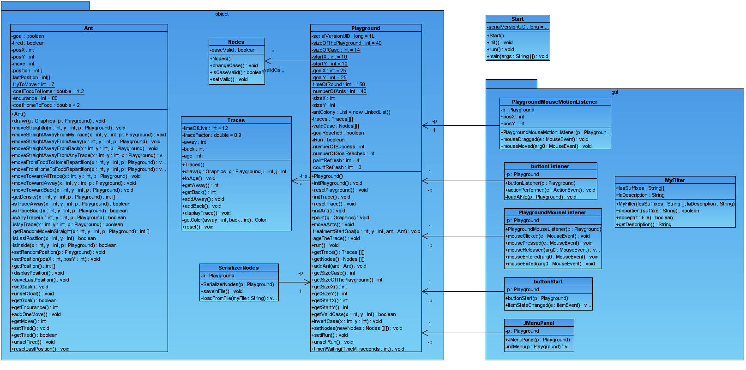
Fig2.8 Full Class Diagram (see in Appendix 1)

We can find in Appendix 1 the full class diagram, showing all the classes and the relationships.

The two main classes
The code works with 2 main classes: the ant and the playground, plus a very simple one, the traces. After defining these classes, we need to define their attributes and their methods. That means what they own and what they are capable of.

The class Ant

Attributes
An ant is an independent and autonomous object which is capable to move. First let’s have a look to its attribute: each ant is having a position, and two booleans tired and goal. This way, we get to know if the ant is tired and need to come back to the nest, and also if it has reached the goal or not. The position is stored in 2 integers, posX and posY, as well as in an array of 2 integers position[]. The last position is also saved, as the ant even if not the cleverest creature, still remembers its last position and does not go back at every step.
private boolean goal, tired;
private int posX, posY, move;
private int[] position, lastPosition;
The static attributes are fixed values which define the factors being used. We will find the endurance of an ant – understand the number of moves it will make before being tired and having to come back to the nest, the number of tries for a new position – that is the time taken to decide which way to take, and also the factors regarding the pheromones impact on the decision process. These all values will be explained at the time they are used, in the Methods part of this chapter.
private static int tryToMove = 7;
// Number of tries to find the best next position {8}
private static int endurance = 80;
// Number of moves before the ant get tired {80}
private static double coefFoodToHome = 1.2;
// Privileges the Back amount over the Away amount {2}
private static double coefHomeToFood = 2;
// Privileges the Away amount over the Back amount {2}
The comments explain the meaning and also give the default values.

All the attributes are given as private; neither the playground nor any other class can access them. This explains the creation of the accessors, which are simple methods allowing the other class to access these values, to change it or just read it:
public void setPosition(int posX, int posY){
public int getPosition()[]{
public void displayPosition(){
public void saveLastPosition(){
public void setGoal(){
public void unSetGoal(){
public void getGoal(){
public int getEndurance(){
public void addOneMove(){
public int getMove(){
public void setTired(){
public boolean getTired(){
public void unsetTired() {
public void resetLastPosition() {
The effects of these accessors are directly explained in the name of each method. By example, setTired() will change the boolean tired to true, unSetTired() will change it to false. If another class wants to know if a particular ant ant1 is tired, this class can call the getTired() method by ant1.getTired(). The return value is a boolean, which value is true if the ant ant1 is tired.

Methods
The ants have some capabilities that are reflected by their methods. Some of them are private and can be called by the ant itself and no one else, and some are public and are called by the playground.
The private methods are there to help the public methods in the move process. In fact, the algorithm for the ants to move is the central idea of the whole program. The more effective the algorithm is, the more acceptable the obtained solutions are. These private methods give random moves, analyses of the playground and the traces, or the validity of a move. The private methods are shown here:
private boolean isTraceAway(int x, int y, Playground p){
private boolean isTraceBack(int x, int y, Playground p){
private boolean isAnyTrace(int x, int y, Playground p){
private boolean isMyTrace(int x, int y, Playground p){
private int[] getRandomMoveInStraight(int x, int y, Playground p){
private boolean isLastPosition(int x, int y){
private boolean isInside(int x, int y, Playground p){
The arguments are always the position, int x and int y, and also the playground p. Indeed the methods need information of the current playground, like its size, the traces it contains…
The getRandomMoveInStraight() method is very important, it is used many times in all movements. It generates a new position following this algorithm:
//GetRandomMoveInStraight()
DO{
Generate a random move.
} WHILE new position is a diagonal move OR not inside the playground OR not on a Valid Case OR the last Position.
Return the new position[].
This way is much better than getting all the possibilities and picking one of them, at it gives equal results and keeps a strong random part. This random part is a base for the whole movement algorithm, as no direction should be privileged.
To go through all the possibilities and get the best one is one solution which forgets the natural part of the move, it should be proscribed.

The algorithm being actually used take consideration of one more detail: if the ant went into a dead end, the number of tries should be limited. We use a threshold of 60 tries before removing the condition of the last position.

To get a valid move inside the playground which respects the chances is one step. To really get the new position, various algorithms are used according to whether the ant found the food or not, the ant is tired, the food has been found… The decision of the algorithm to be used is made in the Playground class, which manages all the moves.

The following methods are the fourth kind of move used by the ants. Three factors decide which move to perform, that is, which algorithm to use: if the ant is tired, if the ant is carrying the food, and also if the goal has ever been reached. All combine it gives 4 possibilities:
- From Home to Food:
  - The goal has never been reached
  - The goal has been reached
- Back Home:
  - The ant is tired
  - The ant has found the food
The 4 algorithms are described in the following.

If the goal has never been reached, that means, the starting point:
The ants have to explore the largest possible area. In order to do that, the ants have to move away from their traces. If the nest is in the middle and there is no obstacle, they will move in a circle which will become larger at each step.
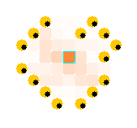
Fig2.9 The ants leaving the nest at t=5

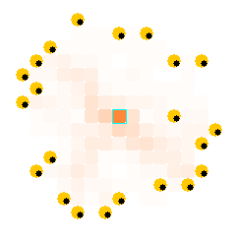
Fig2.10 The ants leaving the nest at t=10
We again want to keep a strong random part in the decision process of each movement. The MoveStraightAwayFromAway() method uses the precedent algorithm and take in consideration the presence of traces:
//MoveStraightAwayFromAway()
count = 0;
DO{
Get a generated random move.
Increase count.
If count > tryToMove, then break.
} WHILE new position is on pheromones
Set the position to the new values
tryToMove is a static value defined in the Attributes part (see first page of Chapter 2.2.1). The purpose is to explore the bigger area possible, so we just generate new positions and see if these positions are already marked or not. If not, the position is set to the current ant.
This method also respects the probability’s rules as much as possible.

If the ant is tired and needs to come back to the nest
Then the ant needs to come back to the nest, using the shortest path. The algorithm we are using is different from the others as it analyses all the possibilities and pick the best one. The algorithm and its implementation show good results, that is why it has been chosen to keep it.
The method is named moveTowardAway(), as we go with the principle that the density of Away pheromones is higher when the ant is close to the nest. When all the ants leave the nest, they leave the red pheromones, called Away pheromones, and then all go in various directions. So, as the ants advance, the pheromones concentration will be less around them. When they want to come back, the best way is to follow the pheromones and move toward the higher concentration.
The algorithm is as follow:
// MoveTowardAway()
Maximum = 0;
For all the cases around the ant, horizontally and vertically {
Get the pheromones amount;
If the amount is higher than maximum, keep its value and memorize the position;
}
If the position is the same than last position or no position memorized {
Give a random new position.
}
This algorithm shows good effectiveness: whenever the ants are tired they are able to come back to the nest, depending on the playground configuration.

If the ant found the food and needs to come back to the nest
Subsequently the ant will follow the same red traces – away traces, but it will use the blue traces as well. The ants can let two types of pheromones behind it, whether it got the food or not.
By using the back pheromones, we insure convergence to one single path. However, the convergence should not be too fast and both amounts of pheromones back and away should be analysed. The algorithm is quite similar to the others, and the factor coefFoodToHome plays a very important role.
//MoveFromFoodToHome()
maximum = 0;
count = 0;
DO{
Increase count;
Generate a random move;
Get the value of both traces away and back of the new position;
Calculate Away * coefFoodToHome – Back;
IF the result is higher than maximum and new position is not last position, remember the new position and update the value of maximum;
} WHILE count < tryToMove;
IF no new position found, moveAwayFromBack();
moveAwayfromBack() is very similar to moveAwayfromAway(), just the condition changes: if there is a Back trace on the new position, we draw a new random position. Following is the Java code of the methods.
//MoveFromFoodToHomeRepartition
public void moveFromFoodToHomeRepartition(int x, int y, Playground p){
int sizeCase = p.getSizeCase();
Traces t;
int count = 0;
double value = 0, max = 0;
int[] newPos = new int[2];
int[] tryNewPos = new int[2];
do{
tryNewPos = getRandomMoveInStraight(x,y,p);
count++;
t = p.getTrace()[tryNewPos[0]][tryNewPos[1]];
value = t.getAway() * coefFoodToHome - t.getBack();
if((value > max)&&(!isLastPosition(tryNewPos[0], tryNewPos[1]))){
max = value;
newPos = tryNewPos;
}
} while(count < tryToMove);
if((newPos[0] == 0)&&(newPos[1] == 0))
this.moveStraightAwayFromBack(x,y,p);
else this.setPosition(newPos[0], newPos[1]);
}
The best solution is given as the one whose value is maximal, i.e. the one where the amount of Away traces multiplied by the factor coefFoodToHome and reduced by the amount of Back traces is the higher. Therefore, we try to follow as much as possible the Away pheromones while trying to avoid the back pheromones. We use the idea that the density of back pheromones is higher when the ant is close to the source of the food, and less when coming to the nest. However, the shortest path will be covered by the Back pheromones as all ants should take it to come back. That is the reason why we use the factor coefFoodToHome, which value is around 2 – depending on the configuration of the playground.
The optimal value depends on many parameters and “2” seems to give good results.

If the goal has been found and the ant carrying the food back to the nest
The algorithm is exactly the same than the previous MoveFromFoodToHomeRepartition(). In the same way the algorithm will try a number of times equal to tryToMove and the best solution will be picked among them.

The Playground class
The playground plays the role of the manager in our application. It will be the one which manages the moves and the output in a graphical mode. We will not go into the details of the code and stick to the algorithm part. The full code of the class can be found in the Appendix part.

Attributes
A playground is defined by a size and the position of the start point and the source of the food point. As it manages the main processes, it also contains the number of Ants being used and the time between each round, and the size of the case for the graphical representation.

The ants are stored into a Linked List instead of an array. It gives the advantage of the declaration while instancing the colony that they represent. One more solution would have been to define the colony as an object instead of defining a single ant. However, we have seen that each ant should be fully independent from the others. Consequently an ant is a simple object and the playground includes a list of them.
Regarding the pheromones, we assign the values to an array of two dimensions. However, we use a special class to keep the pheromones, called Trace. A trace is an object containing two values, away and back, which is able to age with the time. Hence, the playground will contain an array of traces, which can be represented like a 3-dimensional array.
private static int sizeOfThePlayground = 40; // 40
private static int sizeOfCase = 14; // 14
private static int startX = 10, startY = 10; //10,10
private static int goalX = 25, goalY = 25; // 25,25
private static int timeOfRound = 150; // in ms, 150
private static int numberOfAnts = 40; // 40
private List antColony = new LinkedList();
private Traces[][] traces;
private Nodes[][] validCase;
private boolean goalReached, iRun;
private int numberOfSuccess, numberOfGoalReached;
The boolean iRun is used to control the execution of the movement process. In fact, the application uses thread in order to keep the access to the buttons while it is running. iRun starts and stops the movement process.
goalReached is used to inform all the ants that the source of the food has been found. In the real life, ants will communicate about this information while meeting one another. This phenomena is approximated by giving a binary value to goalReached.
numberOfSuccess and numberOfGoalReached are kept to be displayed in real time.

Methods
The Playground class is having all the contructors which are called when starting the application: initPlayground(), initTrace() and initAnt();
It also contains all the accessors, which as seen before are called by the other classes to get a value or to change it.

More important, the Playground class contains three major methods. The first one manages the display and is called after every move. It draws the playground, the ants and the traces and refreshes them whenever required.
//Paint
Draw the white background
FOR each case in the playground {
If it is not a valid case, draw a wall;
Else draw the traces back and away;
}
For each Ant
Calls the draw methods of the ant itself;
Draw the Nest and the source of Food;
Display the numberOfSuccess and numberOfGoalReached values;
Thus the paint() method manages all the display part. The second really important method is the one which manages the movements of the ants. Each step is defined in it:
//moveAnts() – equivalent to one step
Age the traces;
For each ant {
Check if the ant is on Start or Goal point;
Add a Back or Away trace depending on getGoal() binary value;
Increase the numberOfMove by one and check whether the ant is tired or not;
If the ant is tired: moveTowardAway();
Else if the goal has never been reached: moveStraightAwayFromAway();
Else if the ant is carrying the food: moveFromFoodToHomeRepartition();
Else moveFromHomeToFoodRepartition();
}
This method which seems simple actually calls methods more complicated, which has been seen before. The whole process is managed here, but this moveAnts() method and that paint() method are themselves called by the run() function. This run() function is mandatory when using the threads: after creating the thread, the process is free to run by itself as well as its father. The run() is then executed. However, we want to be able to stop the process, and as seen before, we have the boolean iRun whose binary value can be changed, through an accessor. Therefore, the run() method’s code is quite simple and actually manages the whole application:
public void run() {
while(iRun){
timerWaiting(timeOfRound);
moveAnts();
repaint();
}
}
timerWaiting() makes the thread wait for a time period equal to timeOfRound. Then the ants make one new step and the display is refreshed by using repaint(), which will actually call the paint() method.

The application

How to use, how it works
Java provides the capability to use different panels into a same frame. The whole application is included in a JFrame, itself containing two JPanels. The first one is the controller part, with the menu and the Start button. The second is the playground, started as an applet.

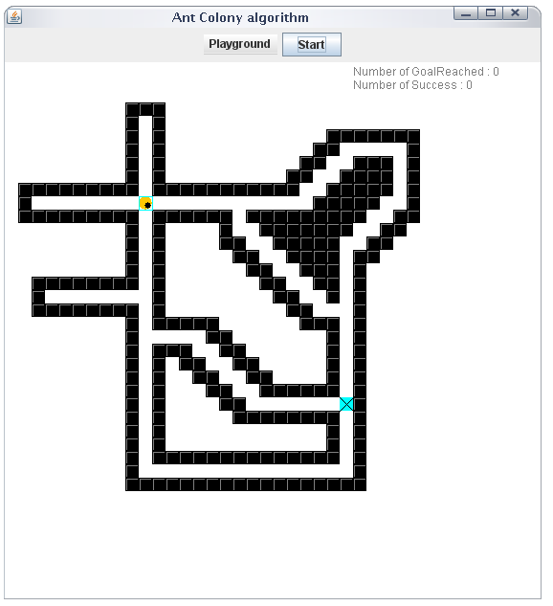
Fig2.11 The Application’s Look
The figure 2.5 shows the look of the application. At the top, the controller part allows the user to start / stop the process and a menu gives the ability to manipulate the playground.
The playground is implementing the mouseListener methods. We use these methods to draw the nodes on the playground with the mouse, by simply clicking on the playground. If the case is already a wall, then the wall will be removed. This way, we can create multiple scenarios and tests the algorithms for various configurations, like the one shown in Figure 2.5.

The playground menu, shown in Figure 2.6, gives the possibility to reset the ants, the traces, or the playground. The “New” option restarts the 3 of them. One great option is the Load/Save capability: the maps we have designed can be saved and reloaded later. We are using zip compression to save the space, in an automatic way; the user does not even know that the map files are zipped. The classes SerializerNodes and MyFilter take care of these options.

The Start/Stop toggleButton controls the execution of the thread by changing the boolean value of iRun, as seen previously.

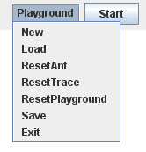
Fig2.12 The Playground options

During the execution, the user can modify the map as much as he wants, by adding or removing the bricks. This authorizes the test of adaptation of the ants to changes, as shown in figure 2.7 and 2.8.
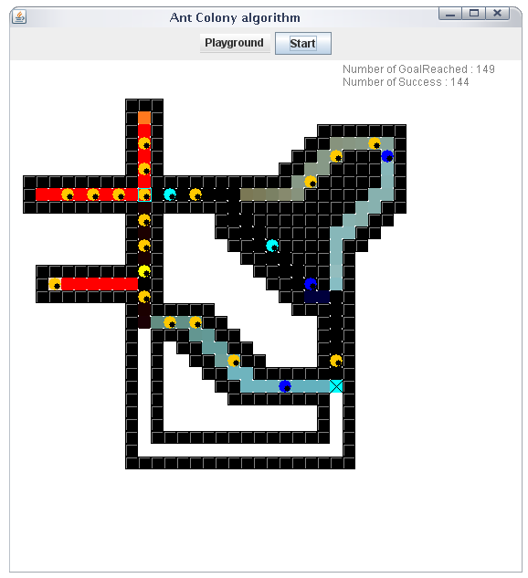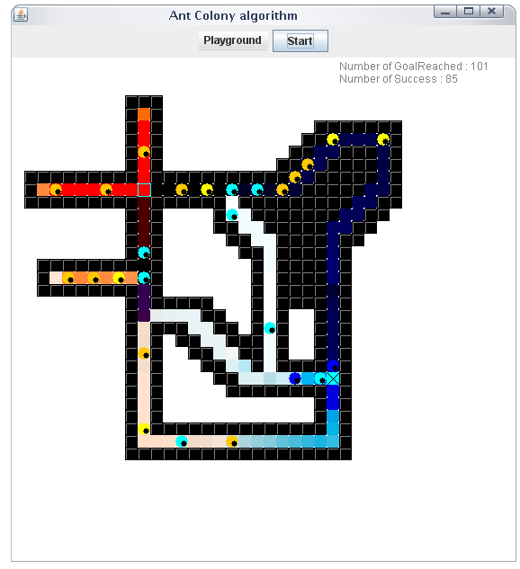
Fig2.13 The Application during a simulation Fig2.14 Changes in the playground

The nest is represented by and the source of the food by.

Results

Positive results
The application does not contain any bug and the ants can evolved in any configuration. However, as the factors cannot be changed by the user, the ground configuration should always be limited. The number of nodes and the size of the playground are chosen by the user, but the number of ants, the speed at which they become tired or the evaporation of the traces always remain the same.
The obtained results are good when the ants are limited to simple ways, like in the wired or wireless networks: they can go only in two directions, except for the nodes where they need to decide which path to take.
The length of the paths is taken in consideration, but the number of nodes is also important.

The algorithms used give in most of the cases good results. The two-bridge experiment explained in the first part of the report is verified, and the ants will converge to the shortest path for more complicated ground.

Configuration which demands adaptation of factors
Some configurations show the limitations of the algorithms used. The configuration shown in Figure 2.9 is like this: at the starting point, the ants have two paths. As they do not know what is behind, the ants will pick randomly one way and the 50-50 repartition will be respected.
However, one way is going directly to the food, although the other one is much shorter but the ants need to go through many nodes. It means that only a few of the 50% of the total ants which chose the best starting path will reach the food quickly. If 50% took the right decision, maybe 5% will have taken all the right paths to go to the food.
After some time, the other 50% of ants will reach the food. The density of pheromones from the way they took is so high, since 50% of the total number of ants let pheromones behind them, that most of them will take again the long path to come back. By doing this, they will let back traces – the blue pheromones, and make the long path the most attracted. This example of convergence toward the longest way is shown in Figure 2.10.
One way of exceeding the problem is to give a high preponderance to blue traces for the ants coming back. However, this means that the ants will converge too quickly and in case of changes of the ground, they will not be able to adapt and find a better path.
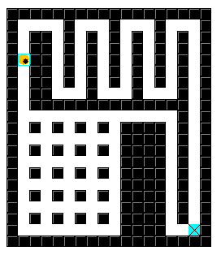
Fig2.15 A difficult playground
However, the rate of the solution given in Figure 2.10 can be good as the number of hops is reduced to the minimum. The delay will though be more important, as its length is more than the other way.
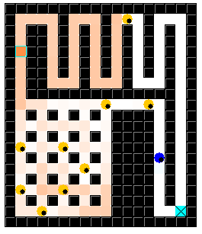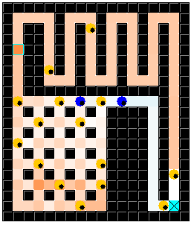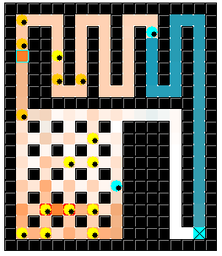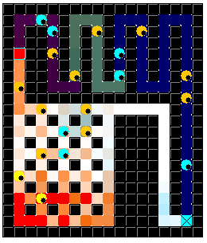
Fig2.16 Convergence with default factors on the difficult playground
The convergence is done toward the less node, none toward the shortest path. By changing the factors we can change this behaviour.

The factors
The factors that really modified the ants’ behaviour and the probability for them to converge toward the best solution are:
- The number of ants: it should depend on the size of the playground and the number of nodes.
- Their endurance: if the food is far away from the nest, the ants need to have enough endurance to go to the nest. If not, they will always come back to the nest without finding the food’s source.
- The traces evaporation speed: the pheromones reduce as the time passes, however it should not be too fast or too slow. The convergence’s speed depends a lot on this factor.
- The factor of away and back attractiveness: the ants privilege the away pheromone to come back to the nest, but it should also take in consideration the amount of back pheromones. The factor will play an important role in the decision process when an ant reaches a node.
- The number of tries before taking a random position, if no good movement found. This factor will also affect the convergence time and the capacity to adapt to any ground’s change.

Comparison with existing implementation of the ants-based algorithm
Some people have already tried to implement the algorithm and have developed their applications, which we can briefly analyse and compare with our own implementation.
The most famous implementation on the internet is called AntSim 1.0, and has been developed in VB by nightlab. It requires the .net framework
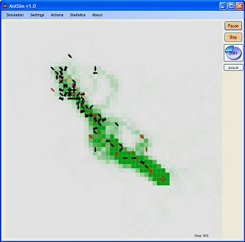
Fig2.17 The AntSim v1.0 application
In this application, the ants will move very quickly and as soon as they discover the food, a solution is analysed. There is an evaluation of the path, which does not exist in our implementation, and which the ants are not capable of.
The application has been released in January 2007 and is famous for its settings capability and the statistics provided while the ants are moving, as shown in figures 2.11 and 2.12.
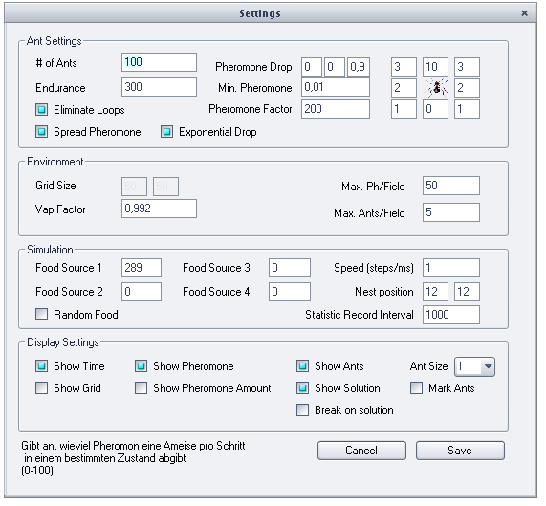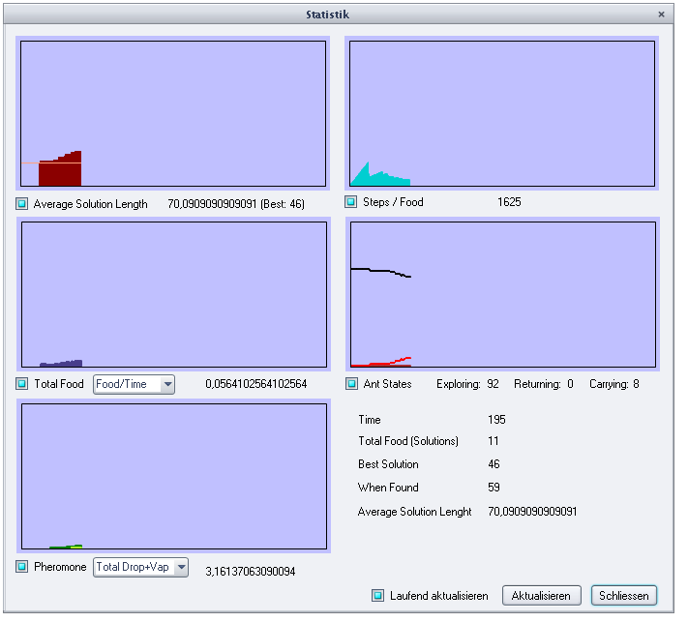
Fig2.18 AntSim v1.0 settings Fig2.19 AntSim v1.0 statistics
However, all the explanations are given in German language, therefore it is not easy to understand all the settings and how the algorithm is used. We still can guess how the ants drop the pheromones by example: the ant will spread the pheromones all around it, with a factor for each of the 8 directions. The accumulation of pheromones is by default set to exponential.

The second implementation is really closed to our application. Also developed in Java, it is called Swarm intelligence Demonstration: Ant Foraging. Some factors can be changed, but the playground is fixed.
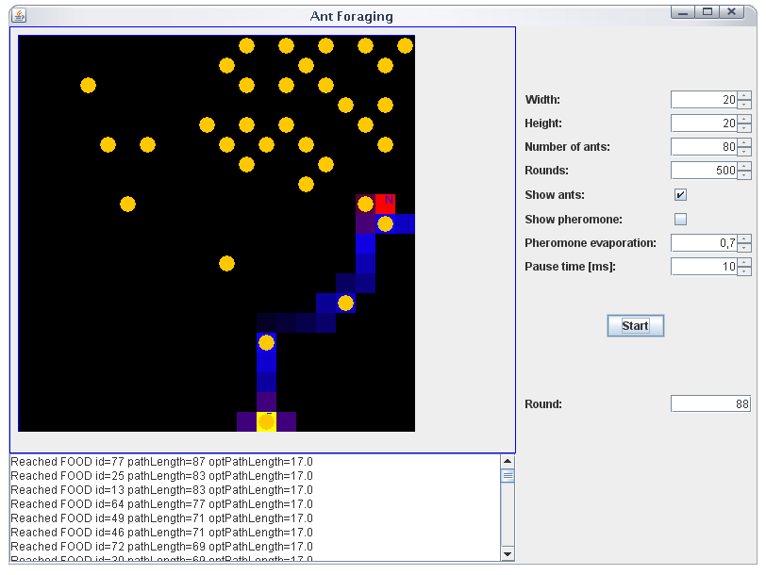
Fig2.20 Ant Foraging
The positions of the nest and the food are chose randomly. The pheromones evaporation is a factor which value is comprised between 0 and 1, although in our case the amount of pheromones is reduced by one every round.

One more implementation of Ants Foraging is given by Thomas Schmickl, from University of Graz, Austria. He is a specialist in biological models and simulation
His implementation presents the diffusion factor, which is also used in AntSim v1.0.
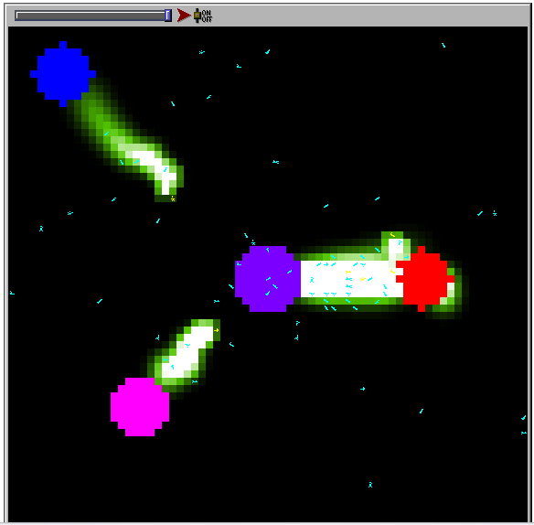
Fig2.21 StarLogo Ant Foraging decision
Thomas Shmickl notes on his website that a high amount of pheromone is placed in the home location and diffused massively, to simulate the fact that ants partially remember its location, by using the polarisation of the sunlight, remembering the surroundings and counting and calculating the steps and turn angles.
In nature, too much pheromone on a trail decreases the following abilities of ants, therefore ensuring after a certain amount of already recruited ants to one source, that the remaining ants are available to the next profitable source. This effect is omitted in this simulation. The simulation was first written by Mitchel Resnick and described in his book Turtles, termites and traffic jams. It is also described in Swarm intelligence by Bonabeau, Dorigo and Theraulaz.

The last example proposed here has been shown to me by one great teacher I had in my college in France, and has been developed by a French people named Rennard. He is a specialist in Artificial Intelligence and neuronal networks. His implementation of the Ant Algorithm is very powerful for finding the shortest path in an open area, even if outsized.
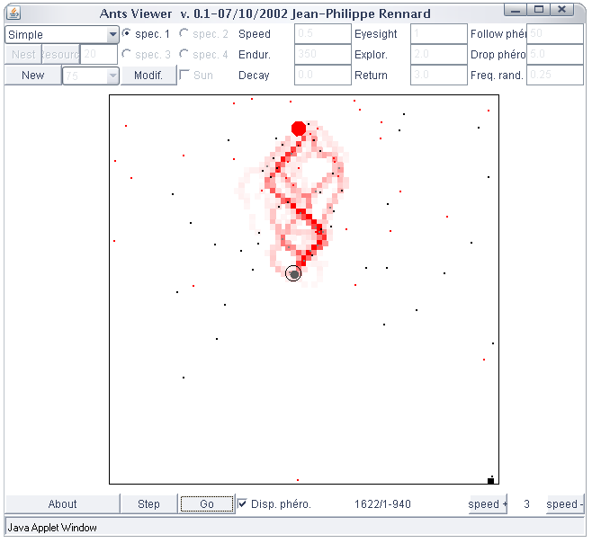
Fig2.22 The Ant Viewer
The ants are capable of finding the nest in a very effective way, and their movements are smooth. The application proposes to give multiple nests with multiple species of ants, and also multiple sources of food. It also gives the example of the two-bridge experiment with parameters set to adapted values.
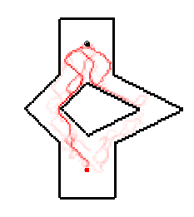
Fig2.23 The two-bridge experiment by Rennard

Enhancements and possible evolutions of the application
The original ants-based algorithm has been fully implemented. However, it has been noticed that one nice improvement would be to vary the amount of pheromones that an ant let on its way, according to its proximity with the nest or the food. The closer it is to the goal, the more pheromones it should let.
This way and with the help of the evaporation process, the amount of pheromones will be more valuable and will give more information.

All the factors presented in the previous paragraph should be accessible to the user who should modify it according to the ground configuration. One more solution would be to adapt the values automatically, but this improvement is very difficult to implement. We will see in the following chapter how this algorithm, now fully explained, has been adapted to the networks routing protocols.

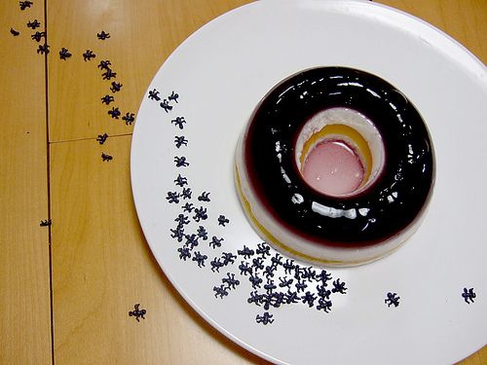
Fig2.24 Ants eating a chocolate donut

analysis of the state-of-the-art Adaptations oF the Ants-based Algorithms to routing protocols

Why and How to apply an Ant-Based algorithm to routing protocols

In the following, we will often talk about the ACO. The full form is Ant Colony Optimisation metaheuristic. The ACO metaheuristic is a multi-agent framework for combinatorial optimization whose main components are: a set of ant-like agents, the use of memory and of stochastic decisions, and strategies of collective and distributed learning.

The networks become nowadays more and more complicated, with moving nodes, varying loads, etc. The users however expect more quality and more services despite the growing complexity of the networks. The theses which will be analysed in the following study some adaptations of the Ant Colony Optimization to routing protocols, and often compare its efficacy to the current routing algorithms.
Most of the papers see in the ACO a great tool for wireless Ad Hoc networks as it has a strong capacity to adapt to changes. However, some new algorithms based on ACO are also analysed for wired networks and are giving encouraging results.

The comparison between ACO and traditional routing algorithms is done with analysing:
- The routing information;
- The routing overhead;
- The adaptivity.

Routing Information
The routing information consists of what is exchanged to get to know the architecture of the network, hence forward the data packets to the best path. For RIP, the nodes exchange the distance-vector information, each node giving to the other their neighbours and so on. In OSPF, the nodes tables need on the link-state information of all the links in every path to compute the shortest path.
In ACO, the paths from a source to a destination are explored independently and in parallel. The figure 3.1 shows a simple configuration of 6 nodes.

E
D
B
A
F
C
Nest
Food
Fig3.25 Nodes
For RIP, the nest A depends on routing tables sent by B and F, as well as the Food depends on C and E’s routing tables.
In OSPF, A needs to know all the link-state between itself and the food to find the shortest path.
In ACO, the paths from the source to the food are explored by using n number of ants, the ants leaving the nest at the same time and taking a random first path. n/2 ants will go through B while the other half will take the way to F. The ants which reach the first the food indicates which way is the shortest without having to wait for the second half of ants to reach. As soon as an ant arrives at a node, the corresponding pheromones value for a path is updated. Hence, each entry of the pheromone table in a node can be updated independently.
In the figure 3.1, the Food point, node D, can immediately use the information in its pheromone table to route data packets to the nest when any ant from either path arrives (and updates its pheromone table).

Information overhead
Routing in RIP involves the transmission of routing tables of each node to every one of its neighbours. For a large network, the routing table of each node, which consists of a list of cost vectors to all other nodes, is large. Since each node needs to transmit its routing table to all of its neighbours, the routing overhead can be very large.
In OSPF, routing is achieved by having each node transmit a link-state packet (LSP) to every other node in a network through a flooding processing. Although an LSP, which carries information about the costs to all the neighbours of a node, is generally smaller than a routing table, the flooding process ensures that every node receives a copy of the LSP. Since an LSP from a node can be disseminated via different paths to other nodes, multiple identical copies of the same LSP may be transmitted to the same node.
Routing in ACO is achieved by transmitting ants rather than routing tables or by flooding LSPs. Even though it is noted that the size of an ant may vary in different systems/implementations, depending on their functions and applications, in general, the size of ants is relatively small, in the order of 6 bytes. This is because ants are generally very simple agents. The following table summarizes the differences between ACO and traditional routing algorithms.
 | RIP / OSPF | ACO algorithm
Routing preference | Based on transmission time / delay | Based on pheromones concentration
Exchange of routing information | Routing information and data packet transmitted separately | Can be attached to data packets
Adapting to topology change | Transmit routing table / Flood LSPs at regular interval | Frequent transmission of ants
Routing overhead | High | Low
Routing update | Update entire routing table | Update an entry in a pheromone table independently

Adaptivity
In dynamic networks, transmitting large routing table (in RIP) or flooding multiple copies of LSPs (in OSPF) in short or regular intervals may incur large routing overhead. However, flooding LSPs and transmitting routing table in longer intervals may result in slower responses to changes in network topology. Since ants are relatively small they can be piggybacked in data packets, more frequent transmission of ants to provide updates of routing information may be possible. Hence, using ACO for routing in dynamic network seems to be appropriate.
Related to the issue of adaptivity is stagnation. Stagnation occurs when a network reaches its convergence; an optimal path ρ is chosen by all ants and this recursively increases an ant’s preference for ρ. This may lead to: 1) congestion of ρ, 2) dramatic reduction of the probability of selecting other paths. The two are undesirable for a dynamic network since:
1) ρ may become nonoptimal if it is congested;
2) ρ may be disconnected due to network failure;
3) other nonoptimal paths may become optimal due to changes in network topology, and iv) new or better paths may be discovered.
Furthermore, Bonabeau et al. have pointed out that the success of ants in collectively locating the shortest path is only statistical. If by chance, many of the ants initially choose a non-optimal, other ants are more likely to select leading to further reinforcement of the pheromone concentration along ρ.
This is undesirable for static networks since it is inefficient ants always choose a stagnant path that is non-optimal.

Presentation of the selected papers
All these papers are long and complex studies, therefore the following will present them in a brief way. Some of them are quite long –up to 300 pages, so for a complete analysis, please refer to the thesis report of these persons.

Ant-based load balancing in telecommunications networks
by Ruud Schoonderwoerd, Owen Holland, Janet Bruten and Leon Rothkrantz, 1997.

Extract of abstract
The ants move across the network between randomly chosen pairs of nodes; as they move they deposit simulated pheromones as a function of their distance from their source node, and the congestion encountered on their journey. They select their path at each intermediate node according to the distribution of simulated pheromones at each node. Calls between nodes are routed as a function of the pheromone distributions at each intermediate node. The performance of the network is measured by the proportion of calls which are lost. The results of using the ant-based control (ABC) are compared with those achieved by using fixed shortest-path routes, and also by using an alternative algorithmically-based type of mobile agent previously proposed for use in network management. The ABC system is shown to result in fewer call failures than the other methods, while exhibiting many attractive features of distributed control.

Summary
The paper resumes the definition and the reason of load balancing in a network. It takes a SDH – Synchronous Digital Hierarchy - network with around 30 nodes connected in a complex mesh (see Figure 3.2), and simulates traffic model by using Smalltalk language.

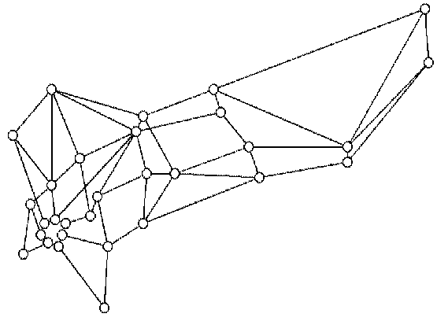
Fig3.26 SDH network simulation for ABC system

It reminds the collective behaviour of the ants and how to apply the algorithm to a network. By using evaporation of the pheromones and ant’s ageing, the system is made more effective. In order to avoid a too strong convergence, the system adds noise and allows the ants to adapt to a change. “Rather than simply tolerating a certain degree of error, it can even be desirable to deliberately add error where none or little exists”. After presenting the algorithm and its parameters, the thesis presents a different approach for distributed control mechanism, the mobile software agents, developed by British Telecom. This mechanism gives the priority to routes whose cost is least. It uses two types of agents: the load management agents which provide the lowest level of control and manage to find shorter paths, and parent agents which control the load management agent. Then they propose one improved version of the original mobile agent algorithm, and will use the two of them to compare with the ABC system.
These three algorithms are simulated on the same network with the same number of calls and the results show a great efficiency; the number of call failures without any load balancing is around 60 in 500 time steps. With the mobile agents, it is reduced to 45; the improved mobile agents give 20. The ABC with the optimized parameters gives around 10 failures for 500 time steps.
The paper then takes interest in the parameters, like the noise, which greatly influences the adaptivity to changes.

Extract of Conclusion
A completely decentralized adaptive control system for telecommunications networks has been implemented, which made use of emergent collective behaviour arising from the interactions between mobile objects modelled on ants, and tables on network nodes.
The principles of the algorithm are simple and general. It is believed that the general framework for ant-based solutions presented here is capable of solving load balancing problems in large networks, both circuit switched and packet switched. How the statistical and topological properties of the network influence the ideal parameter settings is not yet known. But as shown here, even tuning parameters by hand can lead to a well balanced system. The balance obtained is a good example of emergent organisation. The individual ants are remarkably simple, but the resulting structures enable very efficient use of a resource like a telecommunications network. Three possible types of adaptation to the characteristics of such networks have been identified, and ABC systems show themselves capable of good performance on all three types.
A mechanism that is assumed not to be used by natural ants, but could be useful here, is laying ‘anti-pheromone’. One could let ants directly decrease probabilities in the pheromone tables in particular circumstances, rather than increase them.
The pheromone tables do not only represent the best routes, but also contain information about the relative merits of alternative possibilities if something goes wrong.

AntNet A Mobile Agents Approach to Adaptive Routing
By Gianni Di Caro and Marco Dorigo, Bruxelles, December 1997.

Extract of Abstract
This paper introduces AntNet, a new routing algorithm for communications networks. AntNet is an adaptive, distributed, mobile-agents-based algorithm which was inspired by recent work on the ant metaphor. AntNet has been applied to a datagram network and been compared with both static and adaptative state-of-the-art routing algorithm. The experiments have been run for various paradigm temporal and spatial traffic distributions. AntNet showed both very good performance and robustness under all the experimental conditions with respect to its competitor.

Summary
In AntNet, each artificial ant builds a path from its source to its destination node. While building the path, it collects explicit information about the time length of the path components and implicit information about the load status of the network. This information is back-propagated by another and moving in the opposite direction and is used to modify the routing tables of visited nodes.
AntNet show extraordinary results for heavy traffic situation and score absolute performance when internal parameters have been tuned. However, the effectiveness is very sensitive to these parameters.
The paper gives an overview of the routing algorithms and their real purpose: to direct traffic from sources to destinations maximizing network performance while minimizing the costs. The distance-vector and link-state protocols are given in equations.
The paper explains the use of OSPF for managing Internet’s routes, which is said not clearly “the best solution”, but just the “best compromise”. With the growing need of Quality of Service, the use of AntNet to manage the Internet would be preferred.
The following parts of the paper describe the AntNet algorithm and its numerical part. The end of the paper is a simulation of AntNet versus OSPF, SPF (the protocol used at the very beginning of Arpanet), and Daemon, an approximation of the ideal algorithm. The simulation is done for the network represented in figure 3.2.

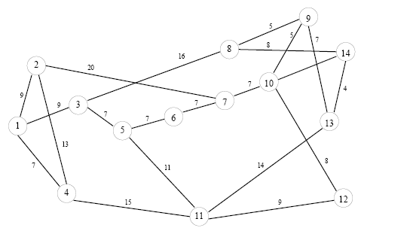
Fig3.27 The virtual network for AntNet simulation
After giving all the parameters and the practical implementation, the results are detailed as followed:
For a low and uniform traffic, all the protocols show almost ideal behaviour. However for high random traffic, AntNet performs at least as well as the other algorithm, otherwise much better. Its results are showing excellent performances and good stability.

Extract of Conclusion
AntNet was always, within the statistical fluctuations, among the best performing algorithm. Differently from the others, AntNet showed always a robust behaviour, being able to rapidly reach a good stable level in performance. Moreover, the proposed algorithm has a negligible impact on network resources and a small set of robustly tuneable parameters. Its features make it an interesting alternative to classical shortest path algorithms.

Routing Algorithms for Mobile Multi-Hop Ad Hoc Networks
Mesut Günes and Otto Spaniol, Berlin, December 2002.

Extract of Abstract
A mobile ad-hoc network (MANET) is a collection of mobile nodes which communicate over radio. These networks have an important advantage; they do not require any existing infrastructure or central administration. Therefore, mobile ad-hoc networks are suitable for temporary communication links. This flexibility, however, comes at a price: communication is difficult to organize due to frequent topology changes.
In this paper we present a new on-demand routing algorithm for mobile, multi-hop ad-hoc networks. The algorithm is based on ant algorithms which are a class of swarm intelligence. Ant algorithms try to map the solution capability of ant colonies to mathematical and engineering problems. The Ant-Colony-Based Routing Algorithm (ARA) is highly adaptive, efficient and scalable. The main goal in the design of the algorithm was to reduce the overhead for routing. Furthermore, we compare the performance of ARA with other routing protocols, including DSDV, AODV, and DSR through simulation results.

Summary
The paper begins with explaining the issues of MANET and the difficulties to manage the routes as the nodes move. It then gives a brief description of the main routing protocols used in MANET:
- DSDV, Destination Sequenced Distance Vector
- AODV, Ad Hoc On Demand Distance Vector Protocol
- DSR, Dynamic Source Routing
The ant algorithm is explained and the advantages for Ad Hoc networks are discussed: the dynamic topology (the ants allow a high adaptation to the topology), local work (the ants take the decisions locally), link quality (by using pheromones evaporation), support for multipath.
ARA – Ant Routing Algorithm for Manet – is the subject of the following. There are 3 phases which are given in details : Route Discovery Phase, Route Maintenance and Route Failure Handling. The ARA algorithm respects the following:
- Distributed operation
- Loop Free
- Demand-based operation
- Sleep period operation
- Locality
- Multi-path
- Sleep mode
The paper ends on a simulation, performed on NS2. 50 mobiles nodes are given in a area of 1500m x 300m, during 15 minutes. The nodes are moving toward random point at a chosen speed. The results compare ARA with DSDV, AODV and DSR.
The delivery rate is at least 0.95%, just under DSR performance, while DSDV and AODV show poor results. If we have a look to the overhead, by seeing the factor routing bits / data bits, ARA is the best algorithm, better than DSR, and DSDV the worst.

Conclusion
The expected overhead of ARA is very small, because there are no routing tables to be exchanged between the nodes.
The simulation shows that ARA gives results as good as those of DSR, but with less overhead. In the context of MANET, this point is very important. The parameters can be improved to get better results.

Ant Colony Optimization for Routing and Load-Balancing: Survey and New Directions
By Kwang Mong Sim and Weng Hong Sun, Member, IEEE, September 2003.

Extract of Abstract
This survey includes:
- Providing a comparison and critique of the state-of-the-art approaches for mitigating stagnation (a major problem in many ACO algorithms);
- Surveying and comparing three major research in applying ACO in routing and load-balancing;
- Discussing new directions and identifying open problems.
The approaches for mitigating stagnation discussed include: evaporation, aging, pheromone smoothing and limiting, privileged pheromone laying and pheromone-heuristic control. The survey on ACO in routing/load-balancing includes comparison and critique of ant-based control and its ramifications, AntNet and its extensions, as well as ASGA and SynthECA. Discussions on new directions include an ongoing work of the authors in applying multiple ant colony optimization in load-balancing.

Summary
The paper gives an overview on routing algorithms which use ACO. It concerned, in September 2003, three protocols:
- Ant Based Control system, explained in Chapter 3.2.1
- AntNet, subject of the Chapter 3.2.2
- ASGA, Ant System with Generic Algorithm and SynthECA, Synthetic Ecology of Chemical Agent.
It then analyses the ACO versus the traditional routing. An approach to mitigate stagnation follows, which are categorized as follows:
- Pheromone control: evaporation, aging, limiting and smoothing pheromone
- Pheromone-heuristic control: the probability for an ant at a cross to choose a way is based on both pheromones concentration and heuristic function. Thus the ants can easily adapt to changes.
- Privileged pheromone laying: selected subnet of ants are allowed to add extra pheromones (elitist system). This relies on 2 factors, the assessment of the quality of the solution of ants, and the number of ants to be selected to deposit extra pheromone and the amount of pheromone that ants are permitted to deposit.
The paper deeply analyses these factors and how to tune their values, then explains how the proposed algorithms work (ABC, AntNet, ASGA and SynthECA).
One very interesting chapter gives the new directions taken in September 2003. A new algorithm is proposed, named Multiple Ant Colony Optimization. It uses more than one colony of ants to search for optimal paths; each colony of ants deposits a different type of pheromones. The ants are attracted by their own pheromones, but will be repulsed by pheromones from other colonies.

Conclusion
Three major groups of research are analysed in this paper, giving a good idea about the routing protocols named ABC, AntNet, AGA and SynthECA.

Ants-Based Routing in Mobile Ad Hoc Networks
By David Jörg, Bern, 2004.
The paper proposes an analysis of 3 traditional routing protocols for MANET: AODV, DSR and ZRP (Zone Routing Protocol), as well as 2 position-based routing: GPSR (Greedy Perimeter Stateless Routing) and TRP (Terminode Routing Protocol).

The second part explains the ACO and gives 4 protocols derivate from ACO: AntNet, ABC, ARA and Termite – Emergent Ad Hoc Networking.
The conclusion of the second part says that AntNet and ABC both show robust and reliable performance in smaller, fixed wired networks. Their development was not intended for the use in large and highly dynamic mobile ad-hoc networks. ARA and Termite were tested in small-sized mobile ad-hoc networks where they operate very well. However, the route discovery phase still relies on packet flooding. ARA makes use of an AODV-like approach in order to find a valid path to the destination. In Termite, the route request ant follows a random walk through the network until a node is containing pheromone for the destination. The latter scheme reduces the routing overhead, although it may lead to long and absurd paths. The scalability of all protocols described is strongly limited by the ant flooding mechanisms. Furthermore, all protocols store a routing entry for every single destination node in the network. This causes a heavy increase of routing table size in large mobile ad-hoc networks.

The Third part of this thesis report focuses on AMRA, the Ants-Based Mobile Routing Architecture. This algorithm is complex, but the explanation provided remains accessible. The whole AMRA protocol is entirely defined.

The fourth, fifth and sixth parts explain the implementation for testing with QualNet, a network simulation software.
The results are given in the seventh chapter of the thesis for four different configurations:
- Small network.
- Large network with restricted random waypoint mobility.
- Large static network with restricted node deplacement.
- Radical topology changes in a large static network.

Conclusions about the AMRA architecture:
- GPSR is not a suitable routing protocol for the lower layer.
- Relaying toward fixed geography point is critical.
- Interaction with GPSR requires some loop detection.
- Reinforcement need to be reviewed.

Using Ant Agents to Combine Reactive and Proactive Strategies for Routing in Mobile Ad Hoc Networks
By Frederic Ducatelle, Gianni Di Caro and Luca Maria Gambardella, Switzerland, April 2004.

Extract of Abstract
This paper describes AntHocNet, an algorithm for routing in mobile ad hoc networks based on ideas from the Ant Colony Optimization framework. In AntHocNet a source node reactively sets up a path to a destination node at the start of each communication session. During the course of the session, the source node uses ant agents to proactively search for alternatives and improvements of the original path. This allows to adapt to changes in the network, and to construct a mesh of alternative paths between source and destination.
Paths are represented in the form of distance-vector routing tables called pheromone tables. An entry of a pheromone table contains the estimated goodness of going over a certain neighbour to reach a certain destination. Data are routed stochastically over the different paths of the mesh according to these goodness estimates. In an extensive set of simulation tests, we compare AntHocNet to AODV, a reactive algorithm which is an important reference in this research area. We show that AntHocNet can out-perform AODV for different evaluation criteria under a wide range of different scenarios. AntHocNet is also shown to scale well with respect to the number of nodes.

Summary
The paper begins to describe the difficulties to develop a routing protocol for MANET due to the equality of all nodes, the fact that each of them can act as a router and the extra-overhead generates by the access to the shared channel with MAC.
Afterwards, it presents the traditional routing protocols such as AODV, DSR, ZRP. It explains that very few algorithms try to keep an updated estimate of the path qualities, and adapt their data load spreading to this.
It introduces the concept of ACO routing and previous attempts to create protocols based on ACO: ARA, PERA, ANSI and termites. The proposed algorithm, AntHocNet, is given in details. It consists of two components: one is reactive and one is proactive. The paper clams to stay closer to ACO than ARA or other previous attempts. The algorithm is given with the formulas being used.
The simulation is done with Qualnet, where 100 nodes are spread in an area of 3000m x 3000m, with a radio range of 300m, and a data rate of 2 Mbit/s at the physical layer (scenario 1). The second scenario gives more intense traffic; the third investigates the scalability of the algorithm.
The results compare AntHocNet with AODV. In terms of end-to-end packet delivery, AntHocNet is twice more efficient than AODV for the second scenario, while the packet delivery ratio remains the same.
For the small scenarios, AntHocNet generates slightly more overhead than AODV, but it will be the opposite for large networks. In outsized MANET, AntHocNet’s mechanisms of path maintenance, path improvement and local repair pay off more.

Conclusion
AntHocNet, a new routing protocol based on ACO, is introduced, and compares to AODV. The results show that AntHocNet outperform AODV in terms of delivery ratio, average delay and jitter, without causing much more overhead. AntHocNet also seems more scalable than AODV: increasing the number of nodes its performance advantage increases and its overhead grows slower than AODV's
Some ideas are given to go further, like taking information from MAC layer about link’s quality, or including destination sequence number, a principle used in DSDV.

Proposal on Multi agent Ants based Routing Algorithm for Mobile Ad Hoc Networks
By Siva Kumar D. and Bhuvaneswaran R.S., Chennai, June 2007.

Extract of Abstract
Single path routing protocol, known as Ad Hoc On-demand Distance Vector, has been widely studied for mobile ad hoc networks. AODV needs a new route discovery whenever a path breaks. Such frequent route discoveries cause route discovery latency. To avoid such inefficiency, in this paper we present Multi agent Ants based Routing Algorithm (MARA), a new algorithm for routing in mobile ad hoc networks. The proposed hybrid protocol reduces route discovery latency and the end-toend delay by providing high connectivity without requiring much of the scarce network capacity. Multi agent Ants based Routing Algorithm (MARA), is based on ideas from Ant Colony Optimization with Multi agent systems technique. In simulation tests we show that Multi agent Ants based Routing Algorithm (MARA), can outperform AODV, one of the most important current state-of-the-art algorithms, both in terms of end-to-end delay and packet delivery ratio.

Summary
This very recent paper begins with an analysis of the MANET routing protocols, AODV, DSR and DSDV. It then explains the working of ACO algorithm and its application to routing world. The paper presented in Chapter 3.2.3 is used as a base for MARA presention, Multi Agent Ant-Based Routing Algorithm.
A simulation is done with GloMoSim, where 50 nodes are randomly placed in an area of 1500m x 300m, which are the same conditions than the experiment presented in 3.2.3.
MARA is compared to AODV, the results obtained by the simulation are the same than the experiment with NS2 by Mesut Günes and Otto Spaniol.: MARA shows a better delivery ratio and a reduced delay of delivery.

List of Ants-based routing algorithms
All the previous papers present new routing algorithm based on ACO. Here is a list of these algorithms and their field of application.

Previous MANET routing protocols
- DSDV, Destination-Sequenced Distance Vector algorithm
- OLSR, Optimized Link State Routing algorithm
- AODV, Ad Hoc On Demand Distant Vector
- DSR, Dynamic Source routing
- ZRP, Zone Routing Protocol
- GPSR, Greedy Perimeter Stateless Routing
- TRP, Terminode Routing Protocol

Routing protocols presented in this paper
- ABC, Ant Based Control System, for wired networks (see 3.2.1)
- AntNet, for MANET (see 3.2.2., 3.2.4, 3.2.5)
- ASGA, Ant System with Generic Algorithm (see 3.2.4)
- SynthECA, Synthetic Ecology of Chemical Agent (see 3.2.4)
- Termite (see 3.2.5)
- AntHocNet for MANET (see 3.2.6)
- MARA, Multi-agent Ants-based Routing Algorithm (see 3.2.7)

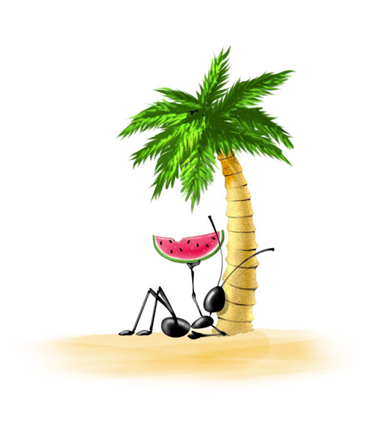
Illustration 3.28 Ant eating a watermelon

Conclusion

This project tried to cover the state-of-the-art studies about Ant Colony Optimisation (ACO) algorithm and its application to routing protocols. It covers recent thesis reports and introduces the latest developed protocols based on ACO.
It has been a great pleasure to study these papers. At the beginning of this project I developed my own application which simulates the ACO, which gave me the best understanding of the algorithm and its issues. Thus, the applications to the routing protocols are easier to understand since the main ideas behind them have always been inspired by the ants.

I hope this report gave you a good understanding of the ACO and therefore, entire satisfaction.

Appendix

Class Diagram

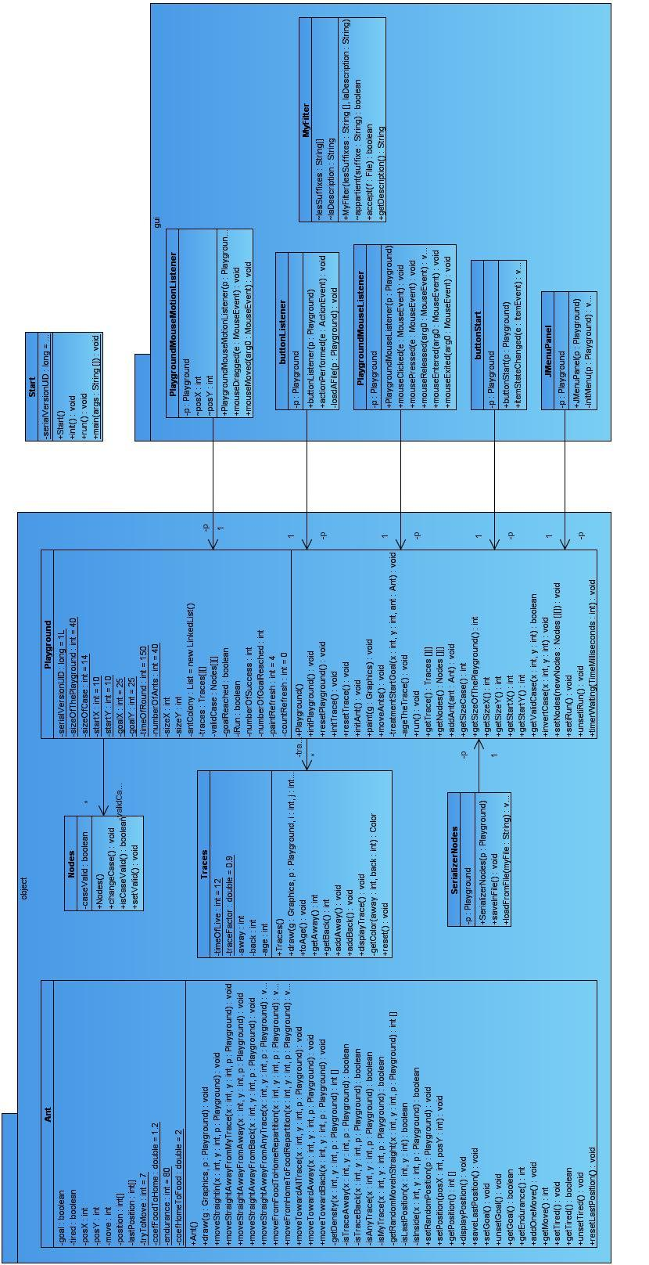

Start.java

import java.awt.BorderLayout;
import java.awt.Component;
import javax.swing.JApplet;
import javax.swing.JFrame;
import object.Playground;
import gui.JMenuPanel;
public class Start extends JApplet{
private static final long serialVersionUID = 1L;
public Start(){
setLayout(new BorderLayout());
//Instance the JPanel Playground and the JPanel JMenuPanel
Playground p = new Playground();
JMenuPanel jMenuPanel = new JMenuPanel(p);
add(jMenuPanel, BorderLayout.NORTH);
add(p, BorderLayout.CENTER);
//Set the size
setSize(p.getSizeX() + p.getSizeCase() * 3, p.getSizeY() + p.getSizeCase() * 5);
}
public void init(){
setLayout(new BorderLayout());
//Instance the JPanel Playground and the JPanel JMenuPanel
Playground p = new Playground();
JMenuPanel jMenuPanel = new JMenuPanel(p);
add(jMenuPanel, BorderLayout.NORTH);
add(p, BorderLayout.CENTER);
//Set the size
setSize(p.getSizeX() + p.getSizeCase() * 3, p.getSizeY() + p.getSizeCase() * 5);
}
public void run(){
setLayout(new BorderLayout());
//Instance the JPanel Playground and the JPanel JMenuPanel
Playground p = new Playground();
JMenuPanel jMenuPanel = new JMenuPanel(p);
add(jMenuPanel, BorderLayout.NORTH);
add(p, BorderLayout.CENTER);
//Set the size
setSize(p.getSizeX() + p.getSizeCase() * 3, p.getSizeY() + p.getSizeCase() * 5);
}
public static void main(String[] args) {
Component applet = new Start();
JFrame jFrame = new JFrame("Ant Colony algorithm");
jFrame.getContentPane().add(applet);
jFrame.setDefaultCloseOperation(JFrame.EXIT_ON_CLOSE);
jFrame.pack();
jFrame.setVisible(true);
}
}

Ant.java [object]

package object;
import java.awt.Color;
import java.awt.Graphics;
import java.util.Random;
public class Ant {
private boolean goal, tired;
private int posX, posY, move;
private int[] position, lastPosition;
private static int tryToMove = 7; // Number of tries to find the best next position {8}
private static int endurance = 80; // Number of moves before the ant get tired {80}
private static double coefFoodToHome = 1.2; // Privileges the Back amount over the Away amount {2}
private static double coefHomeToFood = 2; // Privileges the Away amount over the Back amount {2}
public Ant(){
this.posX = 0;
this.posY = 0;
this.lastPosition = new int[2];
this.goal = false;
this.tired = false;
this.move = 0;
}
/*
* Allow the ants to draw themselves
*/
public void draw(Graphics g, Playground p) {
if(this.getGoal()){
if(this.getTired())
g.setColor(Color.CYAN);
else g.setColor(Color.BLUE);
}
else {
if(this.getTired())
g.setColor(Color.YELLOW);
else g.setColor(Color.ORANGE);
}
int x = (int)(p.getSizeCase()/2);
g.fillOval(posX, posY, p.getSizeCase(), p.getSizeCase());
g.setColor(Color.BLACK);
g.fillOval(posX + x-1, posY + x-1, x, x);
}
/*
* Generate a new position inside the playground on a valid case
*/
public void moveStraightIn(int x, int y, Playground p){
int[] newPos = new int[2];
newPos = getRandomMoveInStraight(x,y,p);
this.setPosition(newPos[0], newPos[1]);
}
/*
* Set a position where there is no trace like the one the ant adds
*/
public void moveStraightAwayFromMyTrace(int x, int y, Playground p){
int [] newTry = new int[2];
int count = 0;
do{
newTry = getRandomMoveInStraight(x,y,p);
if(count++ > tryToMove) break;
}while(isMyTrace(newTry[0], newTry[1], p));
this.setPosition(newTry[0], newTry[1]);
}
/*
* Set a position where there is no Away trace
*/
public void moveStraightAwayFromAway(int x, int y, Playground p){
int [] newTry = new int[2];
int count = 0;
do{
newTry = getRandomMoveInStraight(x,y,p);
if(count++ > tryToMove) break;
} while(isTraceAway(newTry[0], newTry[1], p));
this.setPosition(newTry[0], newTry[1]);
}
/*
* Set a position where there is no Back trace
*/
public void moveStraightAwayFromBack(int x, int y, Playground p){
int [] newTry = new int[2];
int count = 0;
boolean moveNotFound = false;
do{
newTry = getRandomMoveInStraight(x,y,p);
if(count++ > tryToMove){
moveNotFound = true;
break;
}
}
while(isTraceBack(newTry[0], newTry[1], p));
if(moveNotFound)
this.moveStraightIn(x,y,p);
this.setPosition(newTry[0], newTry[1]);
}
/*
* Set a new position where there is no trace
*/
public void moveStraightAwayFromAnyTrace(int x, int y, Playground p){
int [] newTry = new int[2];
int count = 0;
do{
newTry = getRandomMoveInStraight(x,y,p);
if(count++ > tryToMove) break;
}
while(isAnyTrace(newTry[0], newTry[1], p));
this.setPosition(newTry[0], newTry[1]);
}
/*
* Set a new position according to the traces and coefFoodToHome's value
*/
public void moveFromFoodToHomeRepartition(int x, int y, Playground p){
int sizeCase = p.getSizeCase();
Traces t;
int count = 0;
double value = 0, max = 0;
int[] newPos = new int[2];
int[] tryNewPos = new int[2];
do{
tryNewPos = getRandomMoveInStraight(x,y,p);
count++;
t = p.getTrace()[tryNewPos[0]][tryNewPos[1]];
value = t.getAway() * coefFoodToHome - t.getBack();
if((value > max)&&(!isLastPosition(tryNewPos[0], tryNewPos[1]))){
max = value;
newPos = tryNewPos;
}
} while(count < tryToMove);
if((newPos[0] == 0)&&(newPos[1] == 0))
this.moveStraightAwayFromBack(x,y,p);
else this.setPosition(newPos[0], newPos[1]);
}
/*
* Using random tries, get the best path from home to food according to coefHomeToFood's value
*/
public void moveFromHomeToFoodRepartition(int x, int y, Playground p){
int sizeCase = p.getSizeCase();
Traces t;
int count = 0;
double max = 0, value = 0;
int[] newPos = new int[2];
int[] tryNewPos = new int[2];
do{
tryNewPos = getRandomMoveInStraight(x,y,p);
count++;
t = p.getTrace()[tryNewPos[0]][tryNewPos[1]];
value = t.getBack() * coefHomeToFood - t.getAway();
if((value > max)&&(!isLastPosition(tryNewPos[0], tryNewPos[1]))){
max = value;
newPos = tryNewPos;
}
} while(count < tryToMove);
if((newPos[0] == 0)&&(newPos[1] == 0)){
//System.out.println("Failed to find the best path.");
this.moveStraightAwayFromAway(x,y,p);
}
else
this.setPosition(newPos[0], newPos[1]);
}
/*
* Set a new position where the combined traces are more
*/
public void moveTowardAllTrace(int x, int y, Playground p) {
int sizeCase = p.getSizeCase();
Traces t;
int count = 0, max = 0, value = 0;
int[] newPos = new int[2];
for(int i=x-sizeCase; i<x+2*sizeCase; i+=sizeCase){
for(int j=y-sizeCase; j<y+2*sizeCase; j+=sizeCase){
if(isInside(i,j,p)){
if(Math.abs((i-x)/sizeCase) + Math.abs((j-y)/sizeCase) == 1){
count++;
t = p.getTrace()[i][j];
value = t.getBack() + t.getAway();
if(value > max){
max = value;
newPos[0] = i;
newPos[1] = j;
}
}
}
}
}
if((count == 2)||(isLastPosition(newPos[0], newPos[1])) || (newPos[0] == 0)&&(newPos[1] == 0)){
do{
newPos = getRandomMoveInStraight(x,y,p);
count++;
if(count>tryToMove) break;
} while (isLastPosition(newPos[0], newPos[1]));
this.setPosition(newPos[0], newPos[1]);
}
else{
this.setPosition(newPos[0], newPos[1]);
}
}
/*
* Set a new position where away traces are more
*/
public void moveTowardAway(int x, int y, Playground p) {
int sizeCase = p.getSizeCase();
Traces t;
int count = 0, max = 0, value = 0;
int[] newPos = new int[2];
for(int i=x-sizeCase; i<x+2*sizeCase; i+=sizeCase){
for(int j=y-sizeCase; j<y+2*sizeCase; j+=sizeCase){
if(isInside(i,j,p)){
if(Math.abs((i-x)/sizeCase) + Math.abs((j-y)/sizeCase) == 1){
t = p.getTrace()[i][j];
value = t.getAway();
if(value > max){
max = value;
newPos[0] = i;
newPos[1] = j;
}
}
}
}
}
if((isLastPosition(newPos[0], newPos[1])) || (newPos[0] == 0)&&(newPos[1] == 0)){
do{
newPos = getRandomMoveInStraight(x,y,p);
count++;
if(count>tryToMove) break;
} while (isLastPosition(newPos[0], newPos[1]));
this.setPosition(newPos[0], newPos[1]);
}
else{
this.setPosition(newPos[0], newPos[1]);
}
}
/*
* Set a new position where back traces are more
*/
public void moveTowardBack(int x, int y, Playground p) {
int sizeCase = p.getSizeCase();
Traces t;
int count = 0, max = 0, value = 0;
int[] newPos = new int[2];
for(int i=x-sizeCase; i<x+2*sizeCase; i+=sizeCase){
for(int j=y-sizeCase; j<y+2*sizeCase; j+=sizeCase){
if(isInside(i,j,p)){
if(Math.abs((i-x)/sizeCase) + Math.abs((j-y)/sizeCase) == 1){
count++;
t = p.getTrace()[i][j];
value = t.getBack();
if(value > max){
max = value;
newPos[0] = i;
newPos[1] = j;
}
}
}
}
}
if((count == 2)||(isLastPosition(newPos[0], newPos[1])) || (newPos[0] == 0)&&(newPos[1] == 0)){
do{
newPos = getRandomMoveInStraight(x,y,p);
count++;
if(count>tryToMove) break;
} while (isLastPosition(newPos[0], newPos[1]));
this.setPosition(newPos[0], newPos[1]);
}
else{
this.setPosition(newPos[0], newPos[1]);
}
}
/*
* Return the value of traces [away, back] of the position (x,y)
*/
private int[] getDensity(int x, int y, Playground p){
int sizeCase;
int[] value = new int[2];
Traces t;
sizeCase = p.getSizeCase();
for(int i=x-sizeCase; i<x+2*sizeCase; i = i + sizeCase){
for(int j=y-sizeCase; j<y+2*sizeCase; j = j + sizeCase){
if(isInside(i,j,p)){
t = p.getTrace()[i][j];
value[0] = t.getAway();
value[1] = t.getBack();
}
}
}
return value;
}
private boolean isTraceAway(int x, int y, Playground p){
boolean trace = true;
Traces t = p.getTrace()[x][y];
if(t.getAway()==0) trace = false;
return trace;
}
private boolean isTraceBack(int x, int y, Playground p){
boolean trace = true;
Traces t = p.getTrace()[x][y];
if(t.getBack()==0) trace = false;
return trace;
}
private boolean isAnyTrace(int x, int y, Playground p){
boolean trace = true;
Traces t = p.getTrace()[x][y];
if((t.getBack()==0)&&(t.getAway() == 0)) trace = false;
return trace;
}
private boolean isMyTrace(int x, int y, Playground p){
boolean trace = true;
Traces t = p.getTrace()[x][y];
if((this.goal) && (t.getBack()==0)) trace = false;
if((!this.goal) && (t.getAway()==0)) trace = false;
return trace;
}
/*
* Return a new valid position [x,y]
*/
private int[] getRandomMoveInStraight(int x, int y, Playground p){
int sizeCase = p.getSizeCase();
Random generator = new Random();
int[] newPos = new int[2];
do{
newPos[0] = x + sizeCase * (generator.nextInt(3) - 1);
newPos[1] = y + sizeCase * (generator.nextInt(3) - 1);
} while((!isInside(newPos[0], newPos[1], p) || (Math.abs((newPos[0]-x)/sizeCase)+Math.abs((newPos[1]-y)/sizeCase) != 1) || (isLastPosition(newPos[0],newPos[1]))));
return newPos;
}
/*
* Return true if the position (x,y) is equal to the last position
*/
private boolean isLastPosition(int x, int y){
if((lastPosition[0]==x)&&(lastPosition[1]==y)) return true;
else return false;
}
/*
* Return true if the position (x,y) is a valid position
*/
private boolean isInside(int x, int y, Playground p){
boolean inside = true;
int sizeCase = p.getSizeCase();
int sizeX = p.getSizeX(), sizeY = p.getSizeY();
if((x < sizeCase) || (y < sizeCase) || (x > sizeX - sizeCase) || (y > sizeY - sizeCase)) inside = false;
else if(!p.getValidCase(x,y)) inside = false;
return inside;
}
/*
* Give a random position
*/
public void setRandomPosition(Playground p){
Random generator = new Random();
int randX =0, randY=0;
randX = p.getSizeCase() * (1 + generator.nextInt(p.getSizeOfThePlayground()));
randY = p.getSizeCase() * (1 + generator.nextInt(p.getSizeOfThePlayground()));
this.setPosition(randX, randY);
}
/*
* Set the position (x,y)
*/
public void setPosition(int posX, int posY){
this.lastPosition = getPosition();
this.posX = posX;
this.posY = posY;
}
/*
* Return the position [x,y]
*/
public int getPosition()[]{
this.position = new int[2];
this.position[0] = this.posX;
this.position[1] = this.posY;
return this.position;
}
public void displayPosition(){
System.out.print("[" + this.posX + "," + this.posY + "] ");
}
public void saveLastPosition(){
this.lastPosition = this.getPosition();
}
public void setGoal(){
this.goal = true;
}
public void unsetGoal(){
this.goal = false;
}
public boolean getGoal(){
return goal;
}
public int getEndurance(){
return endurance;
}
public void addOneMove(){
this.move = this.move + 1;
}
public int getMove(){
return this.move;
}
public void setTired(){
this.tired = true;
}
public boolean getTired(){
return this.tired;
}
public void unsetTired() {
this.tired = false;
this.move = 0;
}
public void resetLastPosition() {
this.lastPosition[0] = 0;
this.lastPosition[1] = 0;
}
}

Playground.java [object]

package object;
import java.awt.Color;
import java.awt.Dimension;
import java.awt.Graphics;
import java.util.Iterator;
import java.util.LinkedList;
import java.util.List;
import javax.swing.JPanel;
public class Playground extends JPanel implements Runnable {
private static final long serialVersionUID = 1L;
private static int sizeOfThePlayground = 40; // 40
private static int sizeOfCase = 14; // 14
private static int startX = 10, startY = 10; //10,10
private static int goalX = 25, goalY = 25; // 25,25
private static int timeOfRound = 150; // in ms, 150
private static int numberOfAnts = 40; // 40
private List antColony = new LinkedList();
private Traces[][] traces;
private Nodes[][] validCase;
private boolean goalReached, iRun;
private int numberOfSuccess, numberOfGoalReached;
private int sizeX, sizeY;
private int paintRefresh = 4, countRefresh=0;
public Playground(){
this.sizeX = sizeOfThePlayground * sizeOfCase;
this.sizeY = sizeOfThePlayground * sizeOfCase;
this.goalReached = false; this.iRun = false;
setPreferredSize(new Dimension(sizeX,sizeY));
setBackground(Color.WHITE);
this.addMouseMotionListener(new PlaygroundMouseMotionListener(this));
this.addMouseListener(new PlaygroundMouseListener(this));
this.initPlayground();
this.initTrace();
this.initAnt();
}
public void initPlayground() {
this.validCase = new Nodes[this.sizeX + sizeOfCase][this.sizeY + sizeOfCase];
for(int i=0; i < this.sizeX + sizeOfCase; i++)
for(int j=0; j < this.sizeY + sizeOfCase; j++)
this.validCase[i][j] = new Nodes();
}
public void resetPlayground(){
for(int i=0; i < this.sizeX + sizeOfCase; i++)
for(int j=0; j < this.sizeY + sizeOfCase; j++)
this.validCase[i][j].setValid();
}
public void initTrace() {
this.traces = new Traces[this.sizeX + sizeOfCase][this.sizeY + sizeOfCase];
for(int i=0; i < this.sizeX + sizeOfCase; i++)
for(int j=0; j < this.sizeY + sizeOfCase; j++)
this.traces[i][j] = new Traces();
}
public void resetTrace(){
for(int i=0; i < this.sizeX + sizeOfCase; i++)
for(int j=0; j < this.sizeY + sizeOfCase; j++)
this.traces[i][j].reset();
}
public void initAnt() {
this.numberOfSuccess = 0;
this.numberOfGoalReached = 0;
antColony.clear();
List antColony = new LinkedList();
for(int i=0; i < numberOfAnts; i++)
antColony.add(new Ant());
for (Iterator iter = antColony.iterator(); iter.hasNext();) {
Ant ant = (Ant) iter.next();
ant.setPosition(this.getStartX()*this.getSizeCase(), this.getStartY()*this.getSizeCase());
this.addAnt(ant);
}
}
public void paint(Graphics g){
//Background
g.setColor(Color.WHITE);
g.fillRect(0, 0, getSizeX()+getSizeCase(), getSizeY()+getSizeCase());
//Traces and validCase
for(int i=0; i < getSizeX(); i++)
for(int j=0; j < getSizeX(); j++){
if(!this.validCase[i][j].isCaseValid()){
g.setColor(Color.BLACK);
g.fillRect(i,j,getSizeCase(),getSizeCase());
g.setColor(Color.GRAY);
g.drawLine(i+1, j+1, i+getSizeCase()-2, j+1);
g.drawLine(i+1, j+1, i+1, j+getSizeCase()-2);
}
else (this.traces[i][j]).draw(g,this,i,j);
}
//Ant (they draw themselves)
for (Iterator iter = antColony.iterator(); iter.hasNext();) {
((Ant) iter.next()).draw(g, this);
}
//Start Point and Goal Point
g.setColor(Color.CYAN);
g.drawRect(startX * sizeOfCase, startY * sizeOfCase, sizeOfCase, sizeOfCase);
g.fillRect(goalX * sizeOfCase, goalY * sizeOfCase, sizeOfCase, sizeOfCase);
g.setColor(Color.BLACK);
g.drawLine(goalX*sizeOfCase, goalY*sizeOfCase, sizeOfCase*(goalX+1), (1+goalY)*sizeOfCase);
g.drawLine((goalX+1)*sizeOfCase, goalY*sizeOfCase, sizeOfCase*goalX, sizeOfCase*(goalY+1));
//Number of times the goal has been reached
g.setColor(Color.GRAY);
String s2 = "Number of Success : " + String.valueOf(numberOfSuccess);
String s1 = "Number of GoalReached : " + String.valueOf(numberOfGoalReached);
g.drawString(s1, sizeX - 14 * sizeOfCase, sizeOfCase);
g.drawString(s2, sizeX - 14 * sizeOfCase, 2 * sizeOfCase);
}
public void moveAnts(){
ageTheTrace();
int x,y;
Ant ant;
Traces t;
for (Iterator iter = antColony.iterator(); iter.hasNext();) {
ant = (Ant) iter.next();
x = ant.getPosition()[0];
y = ant.getPosition()[1];
//If on goal or on start
treatmentStartGoal(x,y,ant);
// Add a trace, depending on goal
t = this.traces[x][y];
if(ant.getGoal())
t.addBack();
else
t.addAway();
// Add One move and check Endurance
ant.addOneMove();
if(ant.getMove() > ant.getEndurance())
ant.setTired();
// Move
if(ant.getTired()&&(!ant.getGoal())){
ant.moveTowardAway(x,y,this);
}
else if(!goalReached)
ant.moveStraightAwayFromAway(x,y,this);
else {
if(ant.getGoal())
ant.moveFromFoodToHomeRepartition(x,y,this);
else
ant.moveFromHomeToFoodRepartition(x,y,this);
}
}
}
private void treatmentStartGoal(int x, int y, Ant ant) {
// If on Goal
if((x == goalX * sizeOfCase) && (y == goalY * sizeOfCase)){
if(!ant.getGoal()){
numberOfGoalReached++;
ant.setGoal();
this.goalReached = true;
ant.resetLastPosition();
}
}
// If on Start
if((x == startX * sizeOfCase) && (y == startY * sizeOfCase)){
if(ant.getGoal()){
this.numberOfSuccess++;
ant.unsetGoal();
ant.resetLastPosition();
}
if(ant.getTired()){
ant.unsetTired();
ant.resetLastPosition();
}
}
}
private void ageTheTrace() {
// Age the traces
for(int i=0; i < getSizeX(); i+=sizeOfCase){
for(int j=0; j < getSizeX(); j+=sizeOfCase){
Traces trace = this.traces[i][j];
trace.toAge();
}
}
}
public void run() {
while(iRun){
timerWaiting(timeOfRound);
moveAnts();
repaint();
}
}
public Traces[][] getTrace(){
return this.traces;
}
public Nodes[][] getNodes(){
return this.validCase;
}
public void addAnt(Ant ant){
antColony.add(ant);
repaint();
}
public int getSizeCase(){
return sizeOfCase;
}
public int getSizeOfThePlayground(){
return sizeOfThePlayground;
}
public int getSizeX(){
return sizeX;
}
public int getSizeY(){
return sizeY;
}
public boolean getValidCase(int x, int y){
return this.validCase[x][y].isCaseValid();
}
public void invertCase(int x, int y){
this.validCase[x][y].changeCase();
}
public void setNodes(Nodes[][] newNodes) {
this.validCase = newNodes;
}
public void setiRun(){
this.iRun = true;
}
public void unsetiRun(){
this.iRun = false;
}
public void timerWaiting(int TimeMilliseconds){
long t0, t1;
t0=System.currentTimeMillis( );
t1=System.currentTimeMillis( )+(TimeMilliseconds);
do {
t0=System.currentTimeMillis( );
} while (t0 < t1);
}
}

Nodes.java [object]

package object;
import java.io.Serializable;
public class Nodes implements Serializable{
private boolean caseValid;
public Nodes(){
this.caseValid = true;
}
public void changeCase(){
if(this.caseValid) caseValid = false;
else caseValid = true;
}
public boolean isCaseValid(){
return this.caseValid;
}
public void setValid(){
this.caseValid = true;
}
}

Traces.java [object]

package object;
import java.awt.Color;
import java.awt.Graphics;
public class Traces{
private static int timeOfLive = 12; //12
private static double traceFactor = 0.9;
private int away, back, age;
public Traces(){
this.away = 0;
this.back = 0;
this.age = 0;
}
/*
* The Traces draw themselves
*/
public void draw(Graphics g, Playground p, int i, int j) {
if((this.away != 0)||(this.back != 0)){
g.setColor(this.getColor(away, back));
g.fillRoundRect(i, j, p.getSizeCase(), p.getSizeCase(), 2, 2);
}
}
/*
* Add one to age, and if too old, remove the trace
*/
public void toAge(){
this.age = this.age + 1;
if(this.age > timeOfLive){
if(--this.away < 0) this.away = 0;
if(--this.back < 0) this.back = 0;
this.age = 0;
}
}
public int getAway(){
return this.away;
}
public int getBack(){
return this.back;
}
public void addAway(){
this.away = this.away + 1;
}
public void addBack(){
this.back = this.back + 1;
}
public void displayTrace(){
System.out.println("Away : " + this.away + " Back : " + this.back );
}
private Color getColor(int away, int back){
int total, iColorAway, iColorBack, iColorTotal;
Color myColor;
if(away < 51) iColorAway = 255 - 5 * away;
else iColorAway = 0;
if(back < 20) iColorBack = 255 - 12 * back;
else iColorBack = 0;
total = away + back;
if(total < 51 ) iColorTotal = 255 - 3 * total;
else iColorTotal = 0;
myColor = new Color(iColorBack, iColorTotal, iColorAway);
return myColor;
}
public void reset(){
this.away = 0;
this.back = 0;
}
}

SerializerNodes.java [object]

package object;
import java.io.BufferedInputStream;
import java.io.BufferedOutputStream;
import java.io.FileInputStream;
import java.io.FileOutputStream;
import java.io.IOException;
import java.io.ObjectInputStream;
import java.io.ObjectOutputStream;
import java.util.Date;
import java.util.zip.Deflater;
import java.util.zip.ZipEntry;
import java.util.zip.ZipInputStream;
import java.util.zip.ZipOutputStream;
public class SerializerNodes {
private Playground p;
public SerializerNodes(Playground p){
this.p = p;
}
public void saveInFile(){
Nodes[][] iNodes = p.getNodes();
StringBuffer fileNameBuf = new StringBuffer((new Date()).toLocaleString());
for(int i=0; i<fileNameBuf.length(); i++){
if((fileNameBuf.charAt(i) == ' ')||(fileNameBuf.charAt(i) == '.')||(fileNameBuf.charAt(i) == ':'))
fileNameBuf.setCharAt(i, '-');
}
String nameFile = fileNameBuf.toString();
String nameZip = fileNameBuf.toString() + ".map";
try{
FileOutputStream myZip = new FileOutputStream(nameZip.toString());
ZipOutputStream myFileZip = new ZipOutputStream(myZip);
myFileZip.setMethod(ZipOutputStream.DEFLATED);
myFileZip.setLevel(Deflater.BEST_COMPRESSION);
ZipEntry entryZip = new ZipEntry(nameFile);
myFileZip.putNextEntry(entryZip);
BufferedOutputStream bufferedOutput = new BufferedOutputStream(myFileZip);
ObjectOutputStream fileOutput = new ObjectOutputStream(bufferedOutput);
fileOutput.writeObject(iNodes);
fileOutput.flush();
myFileZip.closeEntry();
myFileZip.close();
fileOutput.close();
myZip.flush();
myZip.close();
System.out.println("Map saved in " + nameZip);
}
catch (IOException e) {
e.printStackTrace();
}
}
public void loadFromFile(String myFile) throws IOException, ClassNotFoundException {
ZipInputStream zipFile = new ZipInputStream(new FileInputStream(myFile));
ZipEntry entryZip = zipFile.getNextEntry();
BufferedInputStream buff = new BufferedInputStream(zipFile);
ObjectInputStream oos = new ObjectInputStream(buff);
Nodes[][] newNodes = (Nodes[][]) oos.readObject();
oos.close();
zipFile.close();
buff.close();
p.setNodes(newNodes);
p.repaint();
}
}

PlaygroundMouseListener [gui]

package gui;
import java.awt.event.MouseEvent;
import java.awt.event.MouseListener;
public class PlaygroundMouseListener implements MouseListener {
private Playground p;
public PlaygroundMouseListener(Playground p) {
super();
this.p = p;
}
public void mouseClicked(MouseEvent e) {
int posX, posY;
posX = e.getX()/p.getSizeCase();
posY = e.getY()/p.getSizeCase();
//System.out.println("Invert Case: [" + posX + "," + posY + "]");
p.invertCase(posX*p.getSizeCase(), posY*p.getSizeCase());
p.repaint();
}
public void mousePressed(MouseEvent e) {}
public void mouseReleased(MouseEvent arg0) {}
public void mouseEntered(MouseEvent arg0) {}
public void mouseExited(MouseEvent arg0) {}
}

PlaygroundMouseMotionListener [gui]

package gui;
import java.awt.event.MouseEvent;
import java.awt.event.MouseMotionListener;
public class PlaygroundMouseMotionListener implements MouseMotionListener {
private Playground p;
int posX, posY;
public PlaygroundMouseMotionListener(Playground p) {
super();
this.p = p;
this.posX = 0;
this.posY = 0;
}
public void mouseDragged(MouseEvent e) {
boolean doIt = false;
if(e.getX()/p.getSizeCase() != posX){
posX = e.getX()/p.getSizeCase();
doIt = true;
}
if(e.getY()/p.getSizeCase() != posY){
posY = e.getY()/p.getSizeCase();
doIt = true;
}
if(doIt){
//System.out.println("Invert Case: [" + posX + "," + posY + "]");
p.invertCase(posX*p.getSizeCase(), posY*p.getSizeCase());
p.repaint();
}
}
public void mouseMoved(MouseEvent arg0) {
}
}

JMenuPanel.java [gui]

package gui;
import java.awt.Dimension;
import java.awt.FlowLayout;
import javax.swing.JMenu;
import javax.swing.JMenuBar;
import javax.swing.JMenuItem;
import javax.swing.JPanel;
import javax.swing.JToggleButton;
import object.Playground;
public class JMenuPanel extends JPanel{
private Playground p;
public JMenuPanel(Playground p) {
this.p = p;
this.initMenu(p);
}
private void initMenu(Playground p) {
setPreferredSize(new Dimension(400, 36));
setLayout(new FlowLayout());
JMenuBar jBar = new JMenuBar();
JMenu jFile = new JMenu("Playground");
JMenuItem jNew = new JMenuItem("New");
jNew.addActionListener(new buttonListener(p));
JMenuItem jLoad = new JMenuItem("Load");
jLoad.addActionListener(new buttonListener(p));
JToggleButton jStart = new JToggleButton("Start");
jStart.addItemListener(new buttonStart(p));
JMenuItem jResetTrace = new JMenuItem("ResetTrace");
jResetTrace.addActionListener(new buttonListener(p));
JMenuItem jResetPlayground = new JMenuItem("ResetPlayground");
jResetPlayground.addActionListener(new buttonListener(p));
JMenuItem jResetAnt = new JMenuItem("ResetAnt");
jResetAnt.addActionListener(new buttonListener(p));
JMenuItem jSave = new JMenuItem("Save");
jSave.addActionListener(new buttonListener(p));
JMenuItem jQuit = new JMenuItem("Exit");
jQuit.addActionListener(new buttonListener(p));
jFile.add(jNew);
jFile.add(jLoad);
jFile.add(jResetAnt);
jFile.add(jResetTrace);
jFile.add(jResetPlayground);
jFile.add(jSave);
jFile.add(jQuit);
jBar.add(jFile);
this.add(jBar);
this.add(jStart);
}
}

ButtonListener.java [gui]

package gui;
import java.awt.event.ActionEvent;
import java.awt.event.ActionListener;
import java.io.File;
import java.io.IOException;
import javax.swing.JFileChooser;
import object.MyFilter;
import object.Playground;
import object.SerializerNodes;
public class buttonListener implements ActionListener {
private Playground p;
public buttonListener(Playground p) {
super();
this.p = p;
}
public void actionPerformed(ActionEvent e) {
if("New".equals(e.getActionCommand())){
p.initPlayground();
p.initTrace();
p.initAnt();
p.repaint();
}
else if("Load".equals(e.getActionCommand())){
this.loadAFile(p);
}
else if("ResetTrace".equals(e.getActionCommand())){
p.resetTrace();
p.repaint();
}
else if ("ResetAnt".equals(e.getActionCommand())){
p.initAnt();
p.repaint();
}
else if ("ResetPlayground".equals(e.getActionCommand())){
p.resetPlayground();
p.repaint();
}
else if("Save".equals(e.getActionCommand())){
SerializerNodes sNodes = new SerializerNodes(p);
sNodes.saveInFile();
}
else if("Quit".equals(e.getActionCommand())){
//p.exit();
}
}
private void loadAFile(Playground p){
SerializerNodes serializerNodes = new SerializerNodes(p);
JFileChooser jFile = new JFileChooser();
// Only .map files
MyFilter monFiltre = new MyFilter( new String[]{"map"}, "Map files *.map");
jFile.addChoosableFileFilter(monFiltre);
jFile.setCurrentDirectory(new File("/"));
int retour = jFile.showOpenDialog(jFile);
if (retour == JFileChooser.APPROVE_OPTION){
jFile.getSelectedFile().getName();
jFile.getSelectedFile().getAbsolutePath();
try {
serializerNodes.loadFromFile(jFile.getSelectedFile().getPath());
} catch (IOException e) { e.printStackTrace();
} catch (ClassNotFoundException e) {}
}
}
}

ButtonStart.java [gui]

package gui;
import java.awt.event.ItemEvent;
import java.awt.event.ItemListener;
import object.Playground;
public class buttonStart implements ItemListener {
private Playground p;
public buttonStart(Playground p) {
super();
this.p = p;
}
public void itemStateChanged(ItemEvent e) {
Thread t = new Thread(p);
if (e.getStateChange() == ItemEvent.SELECTED) {
System.out.println("Start");
p.setiRun();
t.start();
} else {
System.out.println("Stop");
p.unsetiRun();
}
}
}

References

Grassé P-P, sur la biologie des termites champignonnistes, Ann. Sc. Zool. Animal, 1944.
? R. Beckers, J.L. Deneubourg, and S. Goss, “Trails and U-turns in the selection of the shortest path by the ant Lasius Niger,” Journal of Theoretical Biology, vol. 159, pp. 397–415, 1992.
J.-L. Deneubourg, S. Aron, S. Goss, and J.-M. Pasteels, “The selforganizing exploratory pattern of the Argentine ant,” Journal of Insect Behavior, vol. 3, p. 159, 1990.
Pasteels, J.M., Deneubourg, J.-L., and Goss, S., Self-organization mechanisms in ant societies (i): rail recruitment to newly discovered food sources, ExperientiaSupplementum, 54, 155, 1987.
http://www.nightlab.ch/antsim/
Mobile Communications Group, http://www-i4.informatik.rwth-aachen.de/mcg/downloads/ants.html
http://zool33.uni-graz.at/schmickl
http://www.rennard.org
D. Subramanian, P. Druschel, and J. Chen, “Ants and reinforcement learning: A case study in routing in dynamic networks,” in Proc. Int. Joint Conf. Artificial Intelligence, Palo Alto, CA, 1997, IJCAI-97, pp. 832–838.
E. Bonabeau, M. Dorigo, and G. Theraulaz, “Inspiration for optimization from social insect behavior,” Nature, vol. 406, pp. 39–42, July 2000.
Deneubourg, 1990
British Telecom, Appleby & Steward, 1994
T. White, B. Pagurek, and F. Oppacher, “ASGA: Improving the ant system by integration with genetic algorithms,” in Proc. 3rd Genetic Programming Conf., July 1998, pp. 610–617.
T. White, “SynthECA: A Society of Synthetic Chemical Agents,” Ph.D.dissertation, Carleton University, Northfield, MN, 2000.
J.S. Baras and H. Mehta, A probabilistic emergent routing algorithm for mobile ad hoc networks, in Proceedings of WiOpt03: Modeling and Optimization in Mobile, Ad Hoc and Wireless Networks, 2003.
C.-C. Shen, C. Jaikaeo, C. Srisathapornphat, Z. Huang and S. Rajagopalan, Ad hoc networking with swarm intelligence, in Ants Algorithms - Proceedings of ANTS 2004, LNCS 3172, (Springer-Verlag, 2004).
M. Roth and S. Wicker, Termite: Ad-hoc networking with stigmergy, in Proceedings of Globecom, 2003. The following papers have been presented in the Chapter 3. Ant-based load balancing in telecommunications networks p.43 AntNet: A Mobile Agents Approach to Adaptive Routing p.45 Routing Algorithms for Mobile Multi-Hop Ad Hoc Networks p.48 Ant Colony Optimization for Routing and Load-Balancing: Survey and New Directions p.50 Ants-Based Routing in Mobile Ad Hoc Networks p.51 Using Ant Agents to Combine Reactive and Proactive Strategies for Routing in Mobile Ad Hoc Networks p.53 Proposal on Multi agent Ants based Routing Algorithm for Mobile Ad Hoc Networks p.55

